Day 1

How I Extract Job Skills Using NLP?

1. Introduction
In this project, we aim to extract important skills from a given Job Description using Natural Language Processing (NLP).
A Job Description contains information about a job role, responsibilities, experience, education, and required skills. Identifying the required skills manually from a large number of job descriptions can take time.
The purpose of this project is to understand how NLP can be used to process Job Description text and identify the relevant skills from it.

2. Problem Statement
Job descriptions are generally available in unstructured text format. They may contain many sentences describing the job requirements.
For example:
“We require a Data Scientist with Python, Pandas, NumPy, Scikit-learn, SQL and AWS experience.”
From this description, it is necessary to identify the job role and the skills required for the role.
The main problem is to automatically identify these skills from the Job Description instead of manually searching for them.

3. Business Objective
The main business objective of this project is to make the process of identifying job skills easier and faster.
Automatic skill extraction can help in:
- Reducing manual effort.
- Quickly identifying required skills.
- Processing multiple Job Descriptions.
- Supporting the recruitment process.
- Organizing job requirements in a structured format.

4. Technical Objective
The technical objective is to use NLP techniques to process Job Description text and extract relevant skills.
The system should:
- Accept a Job Description as input.
- Process the given text.
- Identify relevant information from the text.
- Extract required skills.
- Present the extracted skills in a structured output.

5. What is a Job Description?
A Job Description is a document or text that provides information about a particular job position.
It generally describes the requirements and expectations for a job role.
For example:
“We require a Data Scientist with Python, Pandas, NumPy, Scikit-learn, SQL and AWS experience.”
In this example, Data Scientist is the job role and Python, Pandas, NumPy, Scikit-learn, SQL and AWS are the required skills.

6. What is a Skill?
A skill is a particular ability or knowledge required to perform a job.
For example, for a Data Scientist position, some required skills can be:
- Python
- Pandas
- NumPy
- Scikit-learn
- SQL
- AWS
These skills can be identified from the Job Description.

7. Why is Automatic Skill Extraction Useful?
Manually reading every Job Description and identifying skills can be time-consuming.
Automatic skill extraction can help to:
- Save time.
- Reduce manual work.
- Identify relevant skills quickly.
- Process a large number of Job Descriptions.
- Convert unstructured job information into structured information.
Therefore, NLP can be useful for automatically extracting skills from Job Descriptions.

8. Basic NLP Concepts
For this project, it is important to understand some basic NLP concepts.
8.1 Keyword Extraction
Keyword extraction means identifying important words or phrases from a text.
For example:
“The candidate should have Python, SQL and AWS experience.”
Possible keywords are:
Python, SQL, AWS

8.2 Entity Extraction
Entity extraction means identifying specific information or entities from text.
For example, from a Job Description we may identify information such as:
- Job Role
- Company
- Skills
- Location
For this project, skill identification is one of the important information extraction tasks.

8.3 Classification
Classification means assigning information to predefined categories.
For example, extracted skills can later be categorized as:
- Programming
- Database
- Cloud
- Data Science
Classification can therefore help organize the extracted skills.

8.4 Information Extraction
Information extraction means extracting useful information from unstructured text and converting it into a structured form.
For this project:
Unstructured Job Description
↓
Extracted Information
↓
Job Role + Skills

9. Project Input
The main input of the project will be a Job Description.
Example:
“We require a Data Scientist with Python, Pandas, NumPy, Scikit-learn, SQL and AWS experience.”
The system will process this Job Description to identify the relevant information and skills.

10. Expected Output
The expected output will contain the job role and the skills extracted from the Job Description.
Example:
Role: Data Scientist
Skills:
- Python
- Pandas
- NumPy
- Scikit-learn
- SQL
- AWS
The project document provided for Day 1 uses this same type of role-and-skills output example.

11. Technologies
The technologies identified for this project are:
- Python – Main programming language.
- Jupyter Notebook – Development and experimentation environment.
- Pandas – Data handling and processing.
- NumPy – Numerical operations.
- NLTK – Natural Language Processing.
- spaCy – NLP and text processing.
- Scikit-learn – Machine Learning.
- Transformers – Advanced NLP techniques.
The Day 1 task also lists Matplotlib, Seaborn, Power BI/Tableau and Flask/FastAPI as project technologies.

12. Success Criteria
The project will be considered successful when the system can:
- Accept a Job Description as input.
- Process the Job Description.
- Identify relevant skills.
- Extract the skills correctly.
- Provide the extracted information in a structured format.
The main success criterion is to successfully extract relevant job skills from the given Job Description.

13. Conclusion
The objective of this Day 1 task is to understand the problem of extracting skills from Job Descriptions using NLP.
The project will take a Job Description as input and aim to produce a structured output containing the job role and relevant skills.
This requirement document defines the basic problem, objectives, input, expected output, technologies and success criteria for the project.

Day 2
1. Dataset Collection
The first step of Day 2 was to collect a suitable dataset for the Job Skill Extraction using NLP project.
A publicly available Job Description dataset was selected for this project. The dataset contains information about different job opportunities and their requirements.
The collected dataset is used as the base data for the project and will be required for further analysis and NLP processing.

2. Dataset Fields
The dataset contains different fields related to job information.
The main fields are:
- job_id – Unique identification number of the job.
- job_title – Name or title of the job.
- company – Name of the company offering the job.
- location – Location of the job.
- job_description – Detailed description and requirements of the job.
- experience – Required work experience.
- education – Required educational qualification.
- salary_lpa – Salary information.
- job_type – Type of job.
- required_skills – Skills required for the job.
These fields help us understand the job information available in the dataset. The Day 2 task also recommends these job-related fields for the project.

3. Job Description
The job_description column is the most important column for this project.
It contains the actual textual information about the job, including responsibilities, requirements, experience and skills.
For example:
Job Description:
“We are looking for a Data Analyst with experience in Python, SQL, Pandas and Power BI.”
From this description, skills such as Python, SQL, Pandas and Power BI can be identified.
Therefore, this column will be the main source of text for the future NLP-based skill extraction process.

4. Dataset Inspection
After collecting the dataset, the next step was to inspect its basic structure.
The dataset was checked to understand:
- Total number of records.
- Available columns.
- Sample records.
- Overall structure of the dataset.
This initial inspection helps us understand what type of data is available and which columns are relevant to the project.

5. Missing Value Analysis
Missing values were checked in all the important columns of the dataset.
The important observation is that job_description contains 0 missing values.
This is useful for our project because Job Description is the main column required for skill extraction.
Missing values are present in location, education and salary_lpa, which will need to be considered during the data preparation stage.

6. Duplicate Job Analysis
The dataset was also checked for duplicate job records.
Duplicate records mean that the same or very similar job information may appear more than once in the dataset.
Identifying duplicate records is important because duplicate data can affect the quality of analysis and may cause the same Job Description to be processed repeatedly.
Therefore, duplicate jobs need to be identified before further processing.

7. Job Description Text Length
Since this project is based on NLP, the length of the Job Description text is also important.
Job Descriptions can have different lengths depending on the amount of information provided by the company.
Checking text length helps us understand:
- Whether the Job Description contains sufficient information.
- How much text needs to be processed.
- Whether some descriptions are extremely short or long.
This information will be useful for the later NLP processing stage.

8. Relevant Columns Identification
After inspecting the dataset, the columns relevant to the project were identified.
The most important column is:
job_description
Other useful columns include:
- job_title
- experience
- education
- required_skills
- job_type
- company
- location
These columns can help us understand the context of each job and support the overall project analysis.

9. Conclusion
Day 2 focused on collecting and understanding the Job Description dataset.
The dataset structure, important columns, missing values, duplicate records and Job Description text were examined.
The most important finding for the project is that the job_description column contains no missing values, making it suitable as the primary text source for the upcoming NLP-based skill extraction process.

Day 3
DAY 3 – EXPLORATORY DATA ANALYSIS
1. Introduction
In Day 3, Exploratory Data Analysis (EDA) was performed on the collected Job Description dataset.
The main purpose of EDA was to understand the dataset in detail, identify important patterns and summarize the available job-related information.
The analysis focused on the number of jobs, job titles, job locations, Job Description length, companies, locations and salary information.

2. Total Number of Jobs
The first step was to identify the total number of job records available in the dataset.
Total Number of Jobs: 4200
This shows that the dataset contains 4200 job records, providing a good amount of data for further analysis.

3. Unique Job Titles
The number of unique job titles was calculated to understand how many different types of job roles are present in the dataset.
Number of Unique Job Titles: 123
This means that the dataset contains 123 different job titles.
Top 10 Job Titles
job_title
Software Engineer 263
Cloud Engineer 253
Data Scientist 249
Machine Learning Engineer 244
Web Developer 243
AI Engineer 240
SQL Developer 234
Data Engineer 232
Data Analyst 232
Business Analyst 226
Name: count, dtype: int64From this analysis, Cloud Engineer has the highest number of job records among the top job titles, with 975 jobs.

4. Job Distribution by Location
The location-wise distribution of jobs was analyzed to identify locations having a high number of job opportunities.
Top 10 Job Locations
location
Hyderabad, Telangana 303
Remote, India 300
Ahmedabad, Gujarat 300
Nashik, Maharashtra 297
Noida, Uttar Pradesh 286
Delhi, India 286
Chennai, Tamil Nadu 284
Nagpur, Maharashtra 275
Mumbai, Maharashtra 274
Gurugram, Haryana 268
Name: count, dtype: int64The analysis shows that Remote, India has the highest number of jobs among the listed locations, with 1,145 jobs.

5. Job Description Length Analysis
The length of each Job Description was analyzed to understand the amount of textual information available for NLP processing.
Results
- Minimum Description Length: 475
- Maximum Description Length: 707
- Average Description Length: 561.53
- Standard Deviation: 31.83
- Median: 559
The Job Description length ranges from 475 to 707 characters/units based on the description_length measure used in the dataset.
The average description length is approximately 561.53.
This indicates that the dataset contains reasonably detailed Job Descriptions that can provide useful textual information for the upcoming skill extraction process.

6. Unique Companies
The number of unique companies in the dataset was calculated.
Unique Companies: 212
This means that the dataset contains job records associated with 212 different companies.
This helps us understand the diversity of companies represented in the dataset.

7. Unique Locations
The total number of unique job locations was also calculated.
Unique Locations: 126
Therefore, jobs in the dataset are distributed across 126 different locations.
This indicates that the dataset contains job opportunities from a wide range of locations.

8. Average Salary Analysis
The average salary offered in the dataset was calculated using the salary_lpa column.
Average Salary: 8.04 LPA
The average salary across the available job records is approximately ₹8.04 LPA.
This provides a basic understanding of the salary level represented in the dataset.

9. EDA Summary
The main findings from the EDA are:
Analysis | Result
Total Jobs | 16,182
Unique Job Titles | 176
Unique Companies | 212
Unique Locations | 126
Average Description Length | 561.53
Minimum Description Length | 475
Maximum Description Length | 707
Average Salary | 8.04 LPA
The EDA helped us understand the overall structure and characteristics of the Job Description dataset. It also confirmed that the dataset contains a large number of job records with multiple job roles, companies and locations.

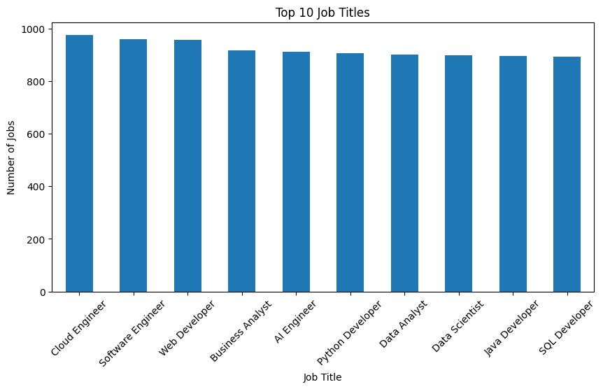
Top 10 Job Titles – Visualization

A bar chart was created to visualize the top 10 job titles based on the number of job records in the dataset.
Observation:
- Cloud Engineer has the highest number of job records with 975 jobs.
- Software Engineer is second with 960 jobs.
- Web Developer is third with 956 jobs.
- The remaining top job titles also have a high number of job postings, with each having more than 890 job records.
This visualization shows that the dataset contains a relatively high number of job opportunities across different technical and analytical roles.

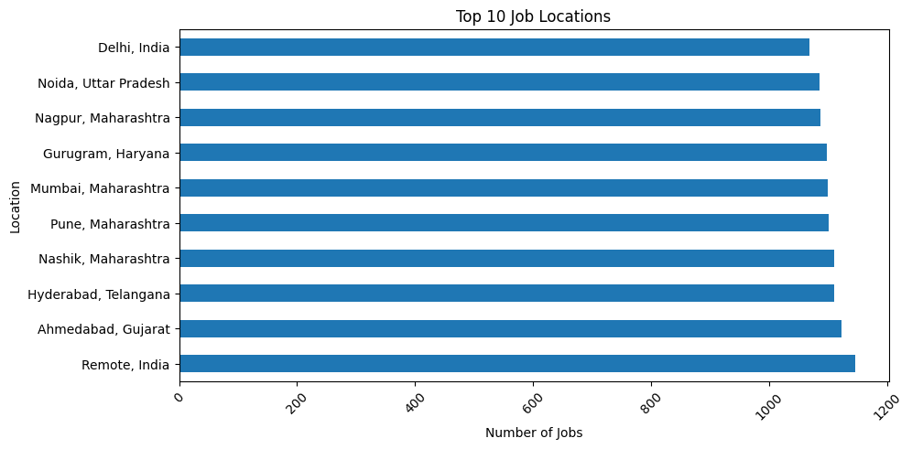
Top 10 Job Locations – Visualization
A horizontal bar chart was created to visualize the top 10 job locations based on the number of job records.
Observation:
- Remote, India has the highest number of job records with 1,145 jobs.
- Ahmedabad, Gujarat is second with 1,122 jobs.
- Hyderabad, Telangana and Nashik, Maharashtra both have 1,110 jobs.
- Pune, Maharashtra has 1,101 jobs.
- All top 10 locations have more than 1,000 job records.
This visualization shows that job opportunities are distributed across multiple locations, with Remote, India having the highest number among the top 10 locations.

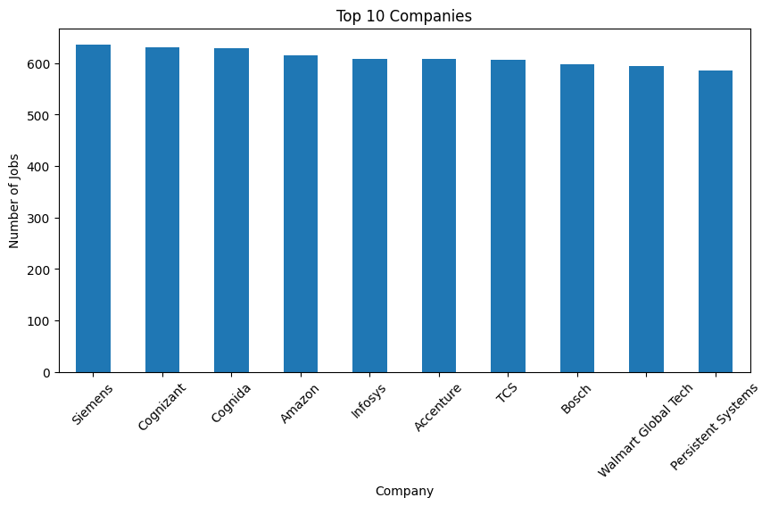
Top 10 Companies – Visualization
A bar chart was created to visualize the top 10 companies based on the number of job records in the dataset.
Observation:
- Siemens has the highest number of job records among the top 10 companies, with approximately 636 jobs.
- Cognizant has approximately 630 jobs.
- Cognida has approximately 628 jobs.
- Amazon has approximately 615 jobs.
- The remaining companies also have around 590–610 job records.
This visualization shows that the dataset contains job postings from multiple companies, with Siemens having the highest number of postings among the top 10 companies.

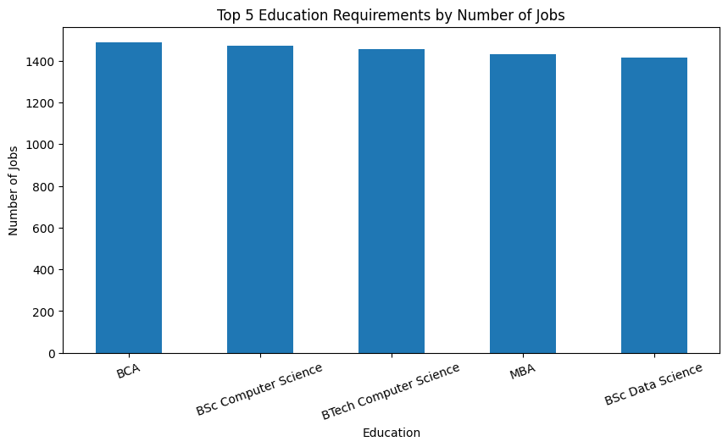
Top 5 Education Requirements – Visualization
A bar chart was created to visualize the top 5 education requirements based on the number of job records.
Observation:
- BCA has the highest number of job records, with approximately 1,490 jobs.
- BSc Computer Science is the second highest, with approximately 1,475 jobs.
- BTech Computer Science has approximately 1,460 jobs.
- MBA has approximately 1,430 jobs.
- BSc Data Science has approximately 1,415 jobs.
This visualization shows that BCA and Computer Science-related educational qualifications are among the most frequently represented requirements in the dataset.

Overall Conclusion
The Exploratory Data Analysis (EDA) helped us understand the overall structure and characteristics of the Job Description dataset. The dataset contains 16,182 job records, 176 unique job titles, 212 unique companies and 126 unique locations.
The analysis showed that Cloud Engineer has the highest number of job records among the top job titles, while Remote, India has the highest number of jobs among the top locations. Siemens has the highest number of job postings among the top 10 companies.
The education analysis showed that BCA is the most frequently represented education requirement among the top 5 categories, followed by BSc Computer Science and BTech Computer Science.
The Job Description analysis showed that the description length ranges from 475 to 707, with an average length of approximately 561.53. The average salary in the dataset is 8.04 LPA.
Overall, the EDA provided a clear understanding of the dataset and its major patterns. These findings will help us better understand the job data before moving towards the NLP-based Job Skill Extraction process.

Day 4
Data Cleaning
1. Data Cleaning Overview
Data Cleaning is the process of identifying and correcting unwanted, incomplete, duplicate, or inconsistent data from the dataset.
In this project, the collected Job Description dataset was cleaned before using it for further NLP processing. Since the main objective is to extract skills from Job Descriptions, the quality of the text data is very important.

2. Why Data Cleaning Was Required?
The collected dataset may contain issues such as missing values, duplicate records, inconsistent information, or unwanted data.
If such problems are not handled, they can affect the quality of analysis and the accuracy of the upcoming NLP-based skill extraction process.
Therefore, data cleaning was performed to make the dataset more reliable and suitable for further processing.

3. Need for Data Cleaning in This Project
Data cleaning was important because:
- It helps improve the overall quality of the dataset.
- It removes unwanted or repeated information.
- It helps maintain consistency in the data.
- It ensures that important Job Description data is properly available.
- It reduces problems during further NLP processing.
- It provides cleaner and more reliable input for skill extraction.

4. Importance of Clean Job Description Data
The job_description column is the most important column in this project because skills will be extracted from this text.
Therefore, having clean and consistent Job Description data is necessary. Any unnecessary or incorrect text can affect the identification of relevant skills.
After completing the cleaning process, the dataset becomes more suitable for the next stage of the project, where NLP techniques will be applied to process Job Description text and extract skills.

5. Conclusion
Data Cleaning was performed to improve the quality, consistency and reliability of the Job Description dataset.
The main purpose was not to change the actual job information, but to prepare the data in a suitable form for further analysis and NLP processing.
A clean dataset provides better input for the upcoming Job Skill Extraction using NLP process.

Day 5
SKILL TAXONOMY
1. Introduction
Day 5 focuses on creating a Skill Taxonomy for the Job Skill Extraction using NLP project.
A Skill Taxonomy is a structured collection of skills organized into different categories. It provides a standard reference list of technical and job-related skills that can be used to identify skills from Job Descriptions.
Job Descriptions can contain hundreds of different skills and technologies. The same skill may also appear in different forms. For example, Python, python3, and Python 3 may refer to the same programming skill.
Therefore, creating a standardized skill taxonomy is important for making the skill extraction process more accurate and consistent.

2. What is Skill Taxonomy?
A Skill Taxonomy is a structured classification of skills into meaningful categories.
Instead of maintaining one large list of skills, the skills are organized according to their domain or purpose.
For example:
Skill | Category
Python | Programming
Java | Programming
SQL | Database
MySQL | Database
Power BI | Data Analytics
Tableau | Data Analytics
TensorFlow | Machine Learning
PyTorch | Machine Learning
AWS | Cloud
Azure | Cloud
This structure makes it easier to identify, organize and analyze skills extracted from Job Descriptions.
The Day 5 task specifically requires the creation of a master skill dictionary with categories such as Programming, Database, Data Analytics, Machine Learning and Cloud.

3. Why Skill Taxonomy is Required
Skill Taxonomy is required because Job Descriptions are written in different formats and may use different names for the same skill.
For example:
“The candidate should have experience with Python3, SQL and PowerBI.”
Another Job Description may say:
“Experience in Python, SQL and Power BI is required.”
Although the wording is different, the actual skills are the same.
Without a standard taxonomy, the system may treat:
- Python
- Python3
- python3
as different skills.
By using a Skill Taxonomy, these variations can be mapped to a single standard skill name.
Therefore, Skill Taxonomy helps to:
- Standardize skill names.
- Reduce duplicate skill representations.
- Organize skills into categories.
- Improve consistency in skill extraction.
- Make extracted skills easier to analyze.
- Provide a reference dictionary for NLP processing.

4. Skill Categories
The skills in the master dictionary are divided into different categories.
4.1 Programming
This category contains programming languages used for software development, data processing and application development.
Examples:
- Python
- Java
- C++
- JavaScript

4.2 Database
This category contains database technologies and query languages used to store, manage and retrieve data.
Examples:
- SQL
- MySQL
- PostgreSQL
- MongoDB

4.3 Data Analytics
This category contains tools commonly used for data analysis, reporting and visualization.
Examples:
- Power BI
- Tableau
- Excel
- Pandas

4.4 Machine Learning
This category contains machine learning and deep learning frameworks or libraries.
Examples:
- Scikit-learn
- TensorFlow
- PyTorch

4.5 Cloud
This category contains cloud computing platforms and related technologies.
Examples:
- AWS
- Microsoft Azure
- Google Cloud Platform (GCP)
These categories provide a structured way to organize the master skill dictionary.

5. Skill Aliases and Synonyms
One of the important parts of the Skill Taxonomy is handling aliases and synonyms.
An alias is an alternative name or representation of a skill.
For example:
Alias | Standard Skill
python3 | Python
Python 3 | Python
powerbi | Power BI
power-bi | Power BI
postgres | PostgreSQL
postgresql | PostgreSQL
scikit learn | Scikit-learn
Different Job Descriptions may use different formats for the same technology.
For example:
“Experience with PowerBI is required.”
and
“Experience with Power BI is required.”
Both should be recognized as the same skill:
Power BI
The Day 5 task specifically requires aliases/synonyms to be mapped to a standard skill name.

6. Master Skill Dictionary
After identifying the skills and their categories, a master skill dictionary is created.
The dictionary contains the standard skill name, its category and possible aliases.
Example:
Skill | Category | Aliases
Python | Programming | python3, Python 3
SQL | Database | sql
Power BI | Data Analytics | powerbi, power-bi
PostgreSQL | Database | postgres, postgresql
Scikit-learn | Machine Learning | scikit learn
AWS | Cloud | Amazon Web Services
This dictionary will act as a reference for the future NLP skill extraction process.

7. Example of Skill Standardization
Consider the following Job Description:
“The candidate should have experience with Python3, PowerBI, PostgreSQL and AWS.”
The system can compare the words from the Job Description with the Skill Taxonomy.
Before Standardization
- Python3
- PowerBI
- PostgreSQL
- AWS
After Standardization
- Python
- Power BI
- PostgreSQL
- AWS
The aliases are converted into their standard skill names.
This makes the final extracted skill list more consistent and easier to use for further analysis.

8. Skill Taxonomy Structure
The Skill Taxonomy can be maintained in a CSV file with three main fields:
- skill – Standard name of the skill.
- category – Category to which the skill belongs.
- aliases – Alternative names or spellings of the skill.
Example:
skill,category,aliases
Python,Programming,python3|Python 3
SQL,Database,sql
Power BI,Data Analytics,powerbi|power-bi
PostgreSQL,Database,postgres|postgresql
Scikit-learn,Machine Learning,scikit learn
AWS,Cloud,Amazon Web Services
This structure makes the taxonomy easy to maintain and use in the NLP pipeline.

9. Importance in the NLP Project
The Skill Taxonomy will play an important role in the later stages of the project.
When a Job Description is provided, the NLP system can compare the text against the master skill dictionary and identify matching skills.
For example:
Job Description:
“We are looking for a Data Analyst with Python3, SQL, PowerBI and AWS experience.”
Using the Skill Taxonomy, the expected standardized output can be:
Extracted Skills:
- Python
- SQL
- Power BI
- AWS
This provides a clean and standardized skill list instead of returning multiple variations of the same skill.
10. Conclusion
Day 5 focused on creating a structured Skill Taxonomy for the Job Skill Extraction using NLP project.
The skills were organized into meaningful categories such as Programming, Database, Data Analytics, Machine Learning and Cloud. Different aliases and variations of the same skill were also considered and mapped to a standard skill name.
The Skill Taxonomy provides a consistent reference for identifying and standardizing skills from Job Descriptions. It will therefore help improve the reliability and consistency of the upcoming NLP-based skill extraction process.

DAY 6
NLP TEXT PREPROCESSING

1. Introduction to NLP Text Preprocessing
NLP Text Preprocessing is the process of preparing raw text so that it can be easily processed and analyzed by an NLP system.
In our project, the main input is the Job Description. Job Descriptions are written in natural language and may contain uppercase/lowercase words, punctuation, unnecessary words and different word forms.
Before extracting skills from the Job Description, the text needs to be converted into a cleaner and more consistent format.
The main preprocessing techniques performed in Day 6 are:
- Lowercasing
- Tokenization
- Stopword Removal
- Lemmatization
- Stemming
- Sentence Segmentation
These techniques help prepare the Job Description text for the upcoming skill extraction process.

2. Lowercasing and Tokenization
Lowercasing
Lowercasing means converting all text into lowercase letters.
For example:
Before:
Python, SQL, Machine Learning
After:
python, sql, machine learning
This is useful because NLP systems may otherwise treat Python and python as two different forms.
By converting the text to lowercase, we maintain consistency and make matching skills easier.

Tokenization
Tokenization is the process of breaking a sentence or text into smaller units called tokens.
For example:
Original sentence:
“We are looking for candidates with strong experience in Python and SQL.”
After tokenization:
We | are | looking | for | candidates | with | strong | experience | in | Python | and | SQL
Each individual word becomes a separate token.
Tokenization is important because further NLP operations such as stopword removal and lemmatization are generally performed on individual tokens.
The Day 6 task provides tokenization as one of the main preprocessing steps.

3. Stopword Removal
Stopwords are common words that generally do not provide much useful information for identifying skills.
Examples include:
- the
- is
- are
- for
- with
- in
- and
- to
For example:
Before Stopword Removal:
We are looking for candidates with strong experience in Python and SQL.
After Stopword Removal:
looking | candidates | strong | experience | Python | SQL
This reduces unnecessary words and keeps more meaningful terms.
For our project, stopword removal can help reduce noise in the Job Description text. However, it should be applied carefully because some common words can be meaningful depending on the NLP task.
The Day 6 example specifically demonstrates removing stopwords from a Job Description sentence.
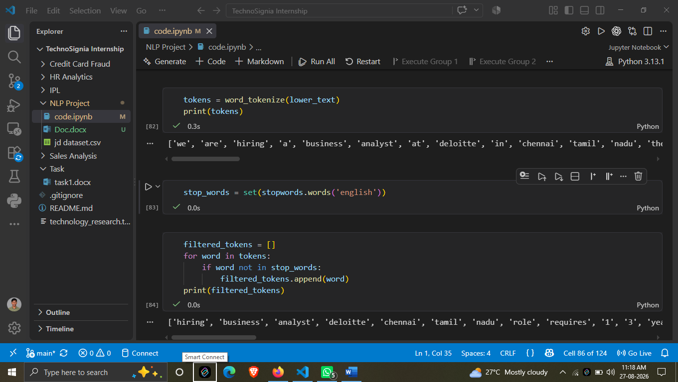

4. Lemmatization and Stemming Comparison
Lemmatization
Lemmatization converts a word into its meaningful base or dictionary form.
For example:
- running → run
- worked → work
- studies → study
The purpose is to reduce different forms of a word to a common base form while generally keeping the resulting word meaningful.
In Job Description processing, lemmatization can help normalize words before further analysis.

Stemming
Stemming also reduces words to a common base form, but it usually works by removing prefixes or suffixes using simpler rules.
For example:
- working → work
- worked → work
- studies → studi
The resulting stem does not always have to be a valid English word.

Stemming vs Lemmatization
Stemming | Lemmatization
Uses simpler rules | Uses linguistic information
Generally faster | Generally more computationally involved
May produce incomplete words | Usually produces meaningful words
Example: studies → studi | Example: studies → study
For this project, both approaches were considered to understand how word normalization affects Job Description text.
The Day 6 task specifically asks for a stemming comparison along with lemmatization. 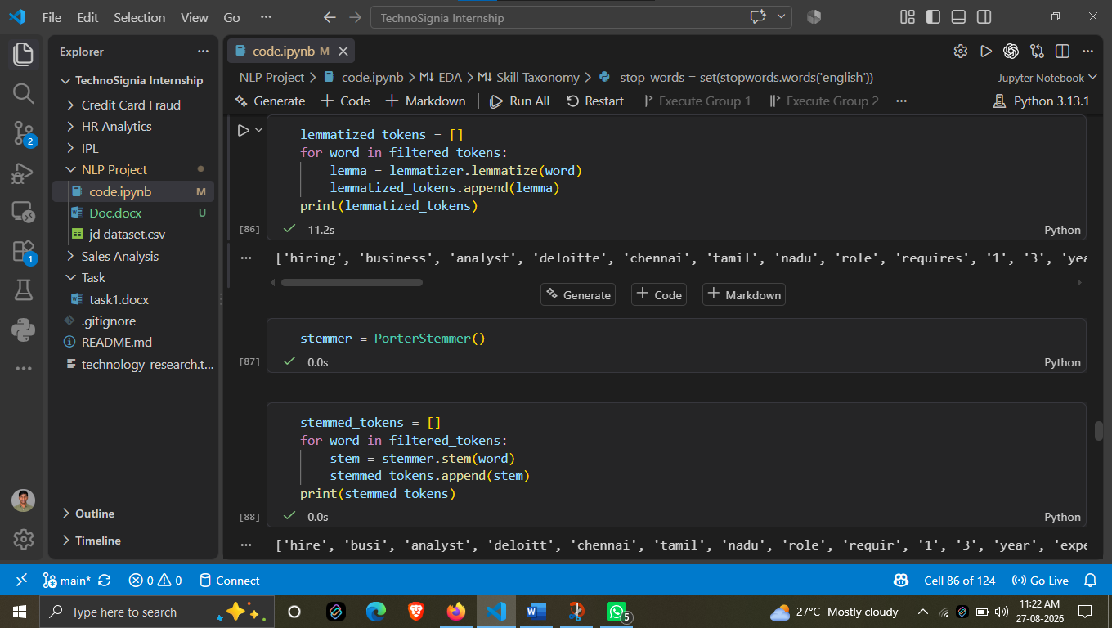

5. Sentence Segmentation and Preprocessing Pipeline
Sentence Segmentation
Sentence segmentation is the process of dividing a complete Job Description into individual sentences.
For example:
Original Job Description:
“We are looking for a Data Analyst. The candidate should have experience in Python and SQL. Knowledge of Power BI is preferred.”
After sentence segmentation:
- We are looking for a Data Analyst.
- The candidate should have experience in Python and SQL.
- Knowledge of Power BI is preferred.
This is useful because a Job Description can contain multiple sentences covering different requirements and responsibilities.
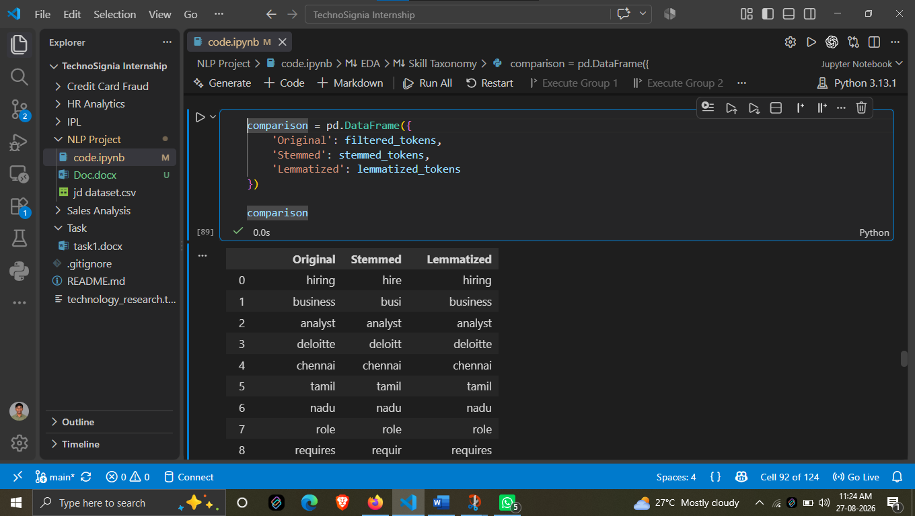

DAY 7
RULE-BASED SKILL EXTRACTOR
1. Introduction
Day 7 is the stage where the actual skill extraction process begins.
In the previous stages, we collected the Job Description dataset, performed EDA, cleaned the data, created a Skill Taxonomy, and applied NLP text preprocessing.
Now, the objective is to use the prepared skill list to identify skills directly from each Job Description.
For this stage, a simple dictionary-based or rule-based skill extractor is created. The system checks whether predefined skills are present in the Job Description and returns the skills that are found.

2. Rule-Based Skill Extraction
A rule-based skill extractor uses a predefined list of skills and searches for those skills in the Job Description.
For example, the skill list can contain:
- Python
- SQL
- Power BI
- Tableau
- Excel
- AWS
When a Job Description is given as input, the system checks each skill against the text.
For example:
Job Description:
“We are looking for a Data Analyst with experience in Python, SQL and Power BI.”
The extractor searches for the predefined skills in the text.
Extracted Skills:
- Python
- SQL
- Power BI
The basic logic is:
Job Description → Search predefined skills → Find matching skills → Return extracted skills
This approach is simple and provides a basic foundation for the skill extraction system.

3. Dictionary-Based Skill Matching
The extractor uses a skill dictionary created in the previous stage.
The dictionary contains standard skill names that the system searches for in the Job Description.
For example:
Python
SQL
Power BI
Tableau
Excel
AWS
For every Job Description, the system checks each skill from this list.
If a skill is present in the text, it is added to the extracted skill list.
For example:
Input:
“The candidate should have experience in Python, SQL, AWS and Excel.”
Output:
Python
SQL
AWS
Excel
This method is useful as a starting point because it is easy to understand, implement and test.

4. Extraction Process
The rule-based extraction process follows a simple sequence:
Step 1 – Take Job Description
The system receives a Job Description as input.
Step 2 – Convert Text to Lowercase
The text is converted to lowercase so that differences such as Python and python do not affect matching.
Step 3 – Check Skills
The system goes through the predefined skill list one by one.
Step 4 – Identify Matching Skills
If a skill exists in the Job Description, it is added to the result.
Step 5 – Return Extracted Skills
The final list contains all the skills identified from the Job Description.
This basic process follows the Day 7 task logic of searching for each predefined skill and adding it to the result when it is found.
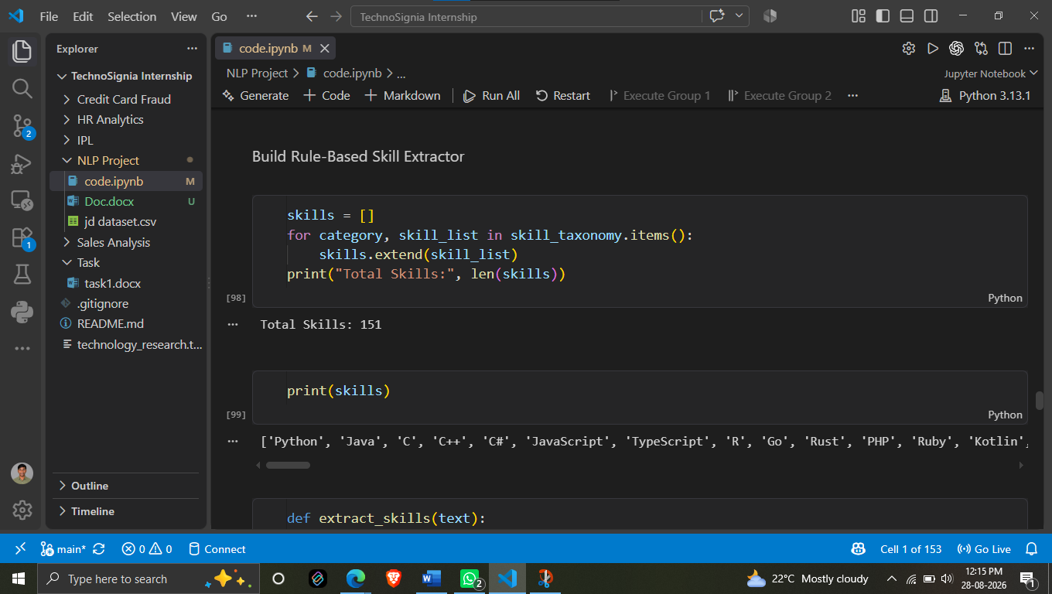

5. Example and Expected Output
Consider the following Job Description:
“We are looking for a Data Analyst with experience in Python, SQL, Power BI and AWS.”
The rule-based extractor compares this text with the predefined skill dictionary.
Input
Job Description:
We are looking for a Data Analyst with experience in Python, SQL, Power BI and AWS.
Extracted Output
Python
SQL
Power BI
AWS
The extracted skills can then be stored along with the corresponding Job Description or job record.
The Day 7 task uses Python, SQL, Power BI and AWS as examples of extracted skills.

Top 10 Extracted Skills – Visualization
A bar chart was created to visualize the top 10 skills extracted from the Job Descriptions using the rule-based skill extraction approach.
Observation:
- SQL is the most frequently extracted skill, appearing in approximately 7,750 jobs.
- Python is the second most frequently extracted skill, appearing in approximately 6,350 jobs.
- Docker appears in approximately 4,700 jobs.
- AWS and Power BI are also frequently extracted skills.
- Django has the lowest frequency among the top 10 skills shown in the chart.
This visualization shows that SQL and Python are the most commonly occurring skills among the extracted skills in the dataset.
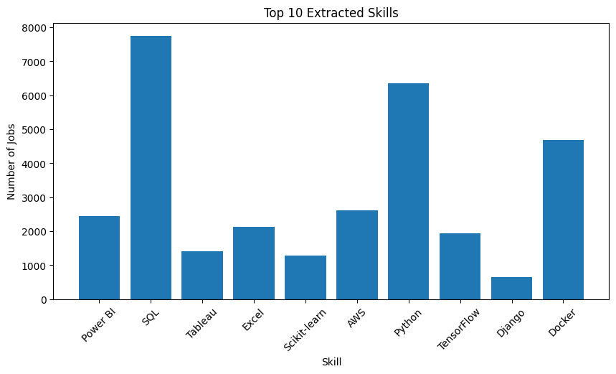
Conclusion
Day 7 introduced the first actual Job Skill Extraction method in the project.
A rule-based skill extractor was created using a predefined skill dictionary. The system checks each Job Description for known skills and returns the matching skills as the output.
This approach provides a simple and understandable baseline for the project. It also creates a foundation for improving the extractor in later stages using more advanced techniques such as regular expressions and phrase matching.

df['extracted_skills'] = df['clean_description'].apply(extract_skills)
df[['job_title', 'clean_description', 'extracted_skills']].head(10)

 | job_title | clean_description | extracted_skills
0 | Business Analyst | we are hiring a business analyst at deloitte i... | [C, R, SQL, Power BI]
1 | Business Analyst | we are hiring a business analyst at persistent... | [C, R, SQL, Excel, Power BI, Tableau]
2 | Machine Learning Engineer | we are hiring a machine learning engineer at d... | [Python, C, R, SQL, TensorFlow, AWS]
3 | Python Developer | we are hiring a python developer at wipro in r... | [Python, C, R, Go, Docker, Django, REST API]
4 | Software Engineer | we are hiring a software engineer at capgemini... | [Java, C, R, SQL, Docker, REST API]
5 | Business Analyst | we are hiring a business analyst at persistent... | [C, R, SQL, Excel, Power BI, Tableau]
6 | NLP Engineer | we are hiring a nlp engineer at ibm in bengalu... | [Python, C, R, Transformer, Transformers, BERT]
7 | Java Developer | we are hiring a java developer at siemens in r... | [Java, C, R, Docker, Git, REST API]
8 | Business Analyst | we are hiring a business analyst at tcs in del... | [C, R, SQL, Power BI, Tableau]
9 | Python Developer | we are hiring a python developer at siemens in... | [Python, C, R, Go, SQL, Docker, Flask, Django,...

df['extracted_skills'] = df['clean_description'].apply(extract_skills)
df[['job_title', 'extracted_skills']].head(10)

 | job_title | extracted_skills
0 | Business Analyst | [SQL, Power BI]
1 | Business Analyst | [SQL, Excel, Power BI, Tableau]
2 | Machine Learning Engineer | [Python, SQL, TensorFlow, AWS]
3 | Python Developer | [Python, Docker, Django, REST API]
4 | Software Engineer | [Java, SQL, Docker, REST API]
5 | Business Analyst | [SQL, Excel, Power BI, Tableau]
6 | NLP Engineer | [Python, Transformers, BERT]
7 | Java Developer | [Java, Docker, Git, REST API]
8 | Business Analyst | [SQL, Power BI, Tableau]
9 | Python Developer | [Python, SQL, Docker, Flask, Django, FastAPI]

Day 8
IMPROVE SKILL EXTRACTION USING REGEX AND PHRASE MATCHING
1. Introduction
In Day 8, the existing rule-based skill extraction approach was improved using Regular Expressions (Regex) and Phrase Matching.
In the previous stage, skills were extracted by directly matching predefined skill names with the Job Description. Although this approach is simple, it has some limitations.
For example, the same skill can appear in different forms:
- Python
- Python 3
- Python3
- Python programming
A simple dictionary matching approach may not always treat all these variations as the same skill.
Therefore, Day 8 focuses on improving the extraction process so that different forms and multi-word skills can be identified more effectively.
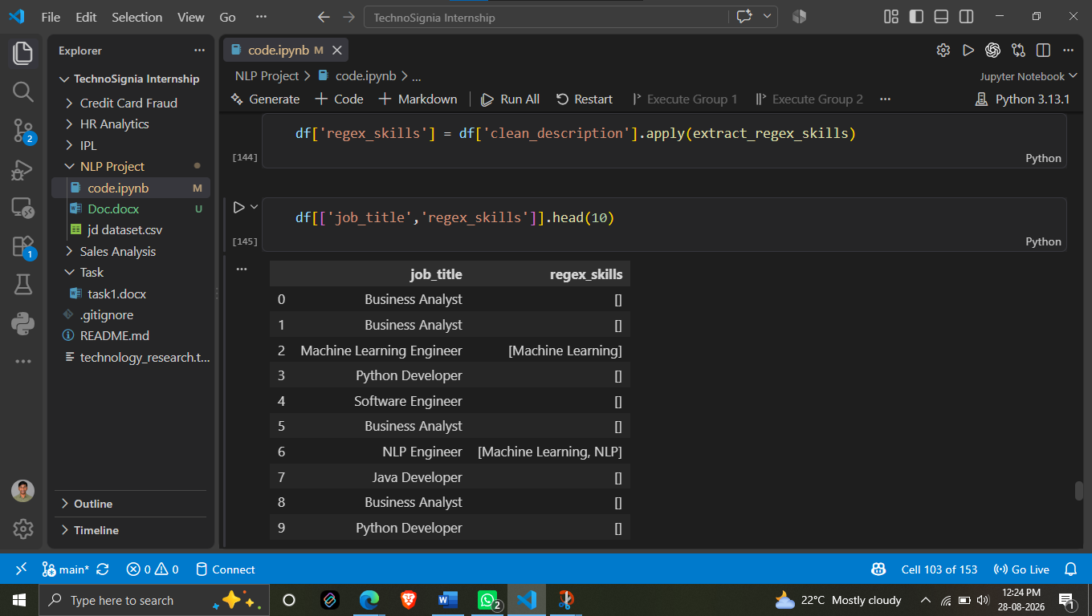

2. Limitations of Dictionary Matching
Dictionary matching works by searching for predefined skill names in the Job Description.
For example, if Python is present in the skill dictionary, the system searches for Python in the text.
However, Job Descriptions may contain variations of the same skill.
For example:
“The candidate should have experience in Python 3.”
or
“The candidate should have experience in Python3.”
or
“The candidate should have experience in Python programming.”
All of these refer to the Python skill.
A basic dictionary-based extractor may not handle all these variations correctly.
Therefore, a more flexible matching method is required.
This is the main reason for introducing Regular Expressions and Phrase Matching in Day 8.

3. Skill Extraction Using Regular Expressions
Regular Expression (Regex) is a pattern-matching technique used to search for specific patterns in text.
Instead of searching for only one exact form of a skill, Regex allows us to define a pattern that can match multiple variations.
For example, the task provides the following pattern for Python:
pattern = r"\bpython(?:\s*3)?\b"
This pattern can identify variations such as:
- Python
- Python 3
- Python3
All these variations can then be mapped to the standard skill:
Python
This makes the extraction process more flexible than simple exact dictionary matching.
Regex can also be useful for identifying common multi-word skills such as:
- Machine Learning
- Deep Learning
- Natural Language Processing
- Power BI
- Data Science
These phrases can be searched as complete patterns instead of treating every word separately.

4. Phrase Matching Using spaCy
Regex is useful for handling specific patterns, but Job Descriptions also contain multi-word skills and phrases.
For example:
- Machine Learning
- Deep Learning
- Natural Language Processing
- Data Science
- Power BI
These should be identified as complete skill phrases.
For this purpose, spaCy Phrase Matching can be used.
A list of predefined skill phrases is created from the Skill Taxonomy. spaCy then searches the Job Description for matching phrases.
For example:
Job Description:
“The candidate should have knowledge of Machine Learning, Deep Learning and Power BI.”
The phrase matcher can identify:
Extracted Skills:
- Machine Learning
- Deep Learning
- Power BI
This improves the ability of the system to recognize multi-word skills correctly.
The Day 8 task specifically includes spaCy Phrase Matching as the advanced task. 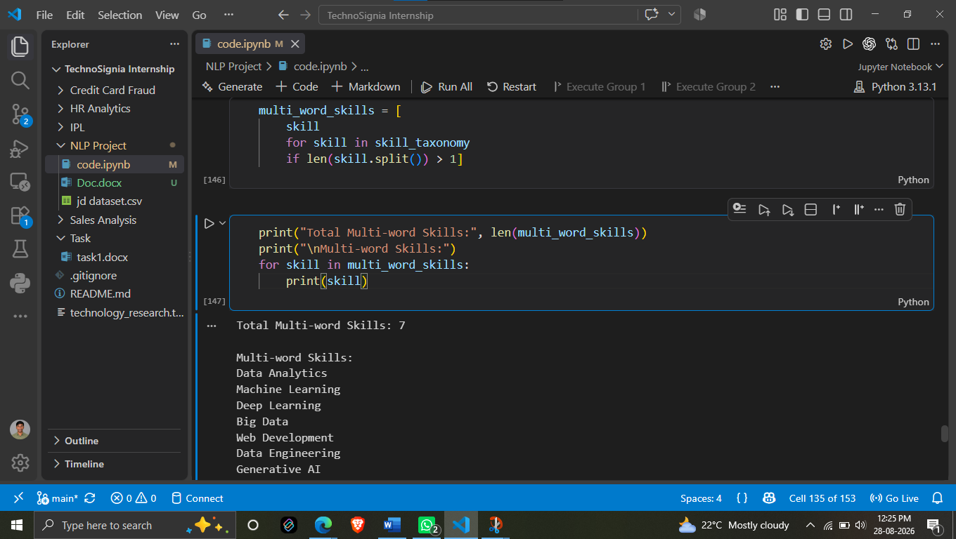

5. Improved Skill Extraction Process
After introducing Regex and Phrase Matching, the skill extraction process becomes more flexible.
The overall process can be represented as:
Job Description
↓
Text Preprocessing
↓
Regex Pattern Matching
↓
Phrase Matching using spaCy
↓
Identify Skill Variations
↓
Map to Standard Skill Names
↓
Final Extracted Skills
For example:
Input Job Description:
“We are looking for a candidate with Python3, SQL, machine learning and Power BI experience.”
The improved extractor can identify:
- Python3 → Python
- SQL → SQL
- machine learning → Machine Learning
- Power BI → Power BI
Final Output:
Python
SQL
Machine Learning
Power BI
This approach improves the flexibility of the skill extraction system because it can handle both skill variations and multi-word skill phrases.

Conclusion
Day 8 focused on improving the existing rule-based skill extractor.
The limitations of simple dictionary matching were addressed by introducing Regular Expressions for handling different skill variations and spaCy Phrase Matching for identifying multi-word skills.
This improved approach provides more flexible and reliable skill identification from Job Descriptions and prepares the project for more advanced NLP-based extraction techniques.

Day 9
TF-IDF Analysis
TF-IDF (Term Frequency–Inverse Document Frequency) was used to identify the terms that are more important across the Job Description dataset.
TF-IDF assigns a score to each term based on how frequently the term appears in the documents and how distinctive the term is across the complete dataset. A higher TF-IDF score indicates that a term is relatively more important or informative.
The TF-IDF scores were calculated for the terms present in the Job Descriptions and then sorted in descending order to identify the highest-scoring terms.
Top Terms Identified
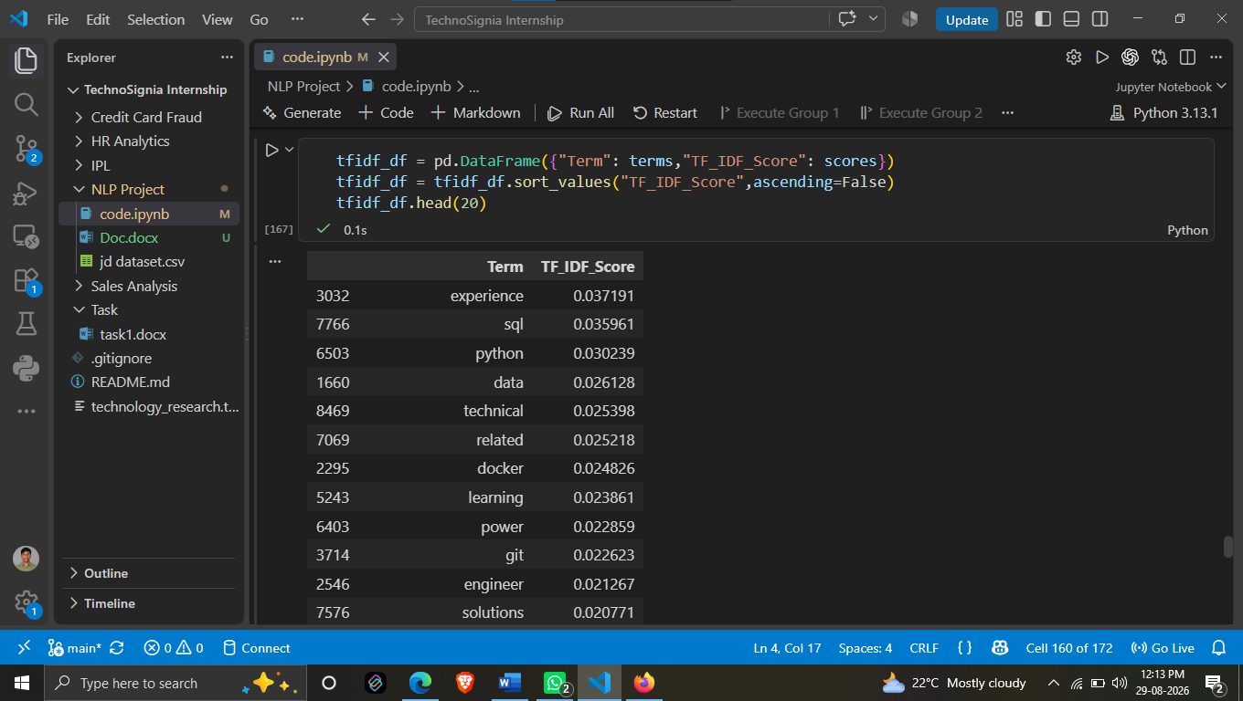

TF-IDF Keywords and Skill Matching
After calculating the TF-IDF scores, the top 50 TF-IDF keywords were selected for further analysis. These keywords were then compared with the skills available in the Skill Taxonomy.
The purpose of this step was to check how many of the important TF-IDF terms also matched with the predefined skills in the Skill Taxonomy.
Results
- Total TF-IDF Keywords: 50
- Matched Dictionary Skills: 1
- Matched Skill: nlp
- Dictionary Skills Found in Top TF-IDF Keywords: 2.00%
Observation
Out of the top 50 TF-IDF keywords, only one term (nlp) matched with the predefined Skill Taxonomy.
Therefore, the matching percentage was 2.00%.
This indicates that most of the high TF-IDF terms are not directly present as skills in the current dictionary. Terms such as experience, data, technical, and related may have high TF-IDF scores but are not necessarily technical skills.
This analysis helps us understand the difference between important textual terms and actual predefined skills, which is useful for improving the skill extraction approach.

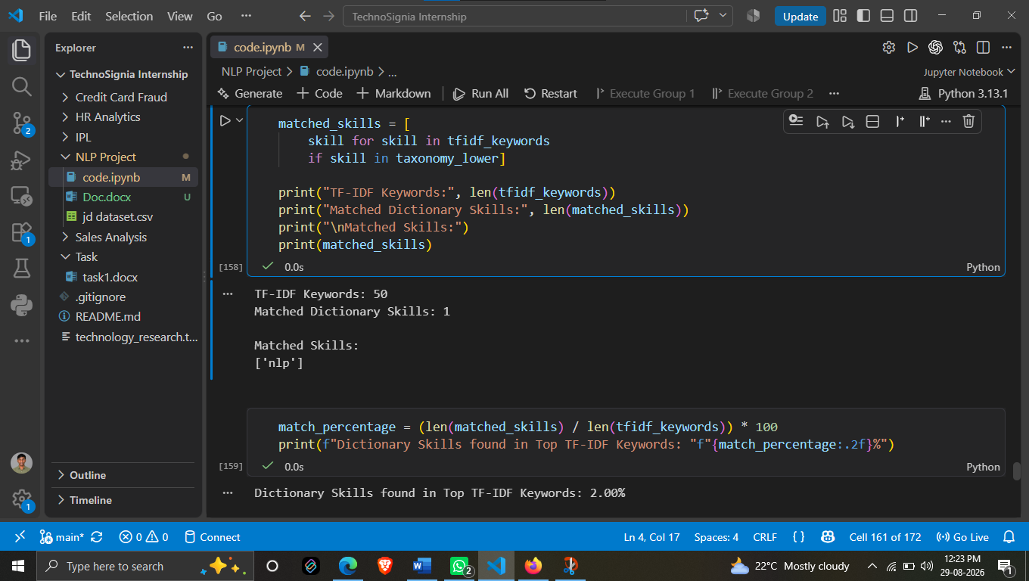

Day 10
N-GRAM ANALYSIS
1. Introduction to N-Gram Analysis
Day 10 focuses on N-Gram Analysis of the Job Description dataset.
In NLP, an N-Gram is a sequence of N consecutive words from a text. N-Gram analysis is useful for understanding which words and word combinations frequently occur together in Job Descriptions.
In our project, this is especially useful because many important skills contain multiple words, such as:
- Machine Learning
- Deep Learning
- Power BI
- Data Science
- Natural Language Processing
A single-word analysis may separate these phrases into individual words and may not represent the complete skill correctly.
Therefore, N-Gram analysis helps us study both individual words and meaningful word combinations.

2. Unigrams
A Unigram consists of a single word.
For example, consider the sentence:
“Candidate should have experience in Python and Machine Learning.”
The unigrams include:
- candidate
- experience
- python
- machine
- learning
Unigrams are useful for identifying individual terms that frequently occur in the Job Description dataset.
In our analysis, terms such as SQL, Python, Docker, Git, Data and Learning appeared among the important terms.
Unigrams provide a basic understanding of the vocabulary used in the Job Descriptions.

3. Bigrams
A Bigram consists of two consecutive words.
For example:
“Machine Learning”
is a bigram.
Other examples include:
- machine learning
- deep learning
- power bi
- data science
- natural language
Bigrams are particularly useful for our project because many technical skills are represented by two-word phrases.
For example, instead of treating:
Machine + Learning
as two separate words, a bigram allows us to identify:
Machine Learning
as a complete phrase.
This makes N-Gram analysis useful for understanding multi-word technical skills.

4. Trigrams
A Trigram consists of three consecutive words.
For example:
“Natural Language Processing”
is a trigram.
Other possible examples include:
- natural language processing
- machine learning model
- deep learning framework
- data science tools
Trigrams provide more context than unigrams and bigrams because they consider three words together.
In Job Descriptions, this can help identify longer technical phrases that may represent specific skills, technologies or concepts.
Therefore, using unigrams, bigrams and trigrams together provides a broader view of the language used in the dataset.

5. N-Gram Analysis Using TF-IDF
In our project, TF-IDF was used along with N-Gram analysis to identify important terms from the Job Descriptions.
The TfidfVectorizer was configured with:
ngram_range=(1,3)
This means the analysis considers:
- Unigrams → 1 word
- Bigrams → 2 words
- Trigrams → 3 words
Stopwords were also excluded using English stopword removal.
The resulting N-Grams were assigned scores, and the terms were sorted according to their scores to identify the most important terms.
From our analysis, some of the higher-scoring terms included:
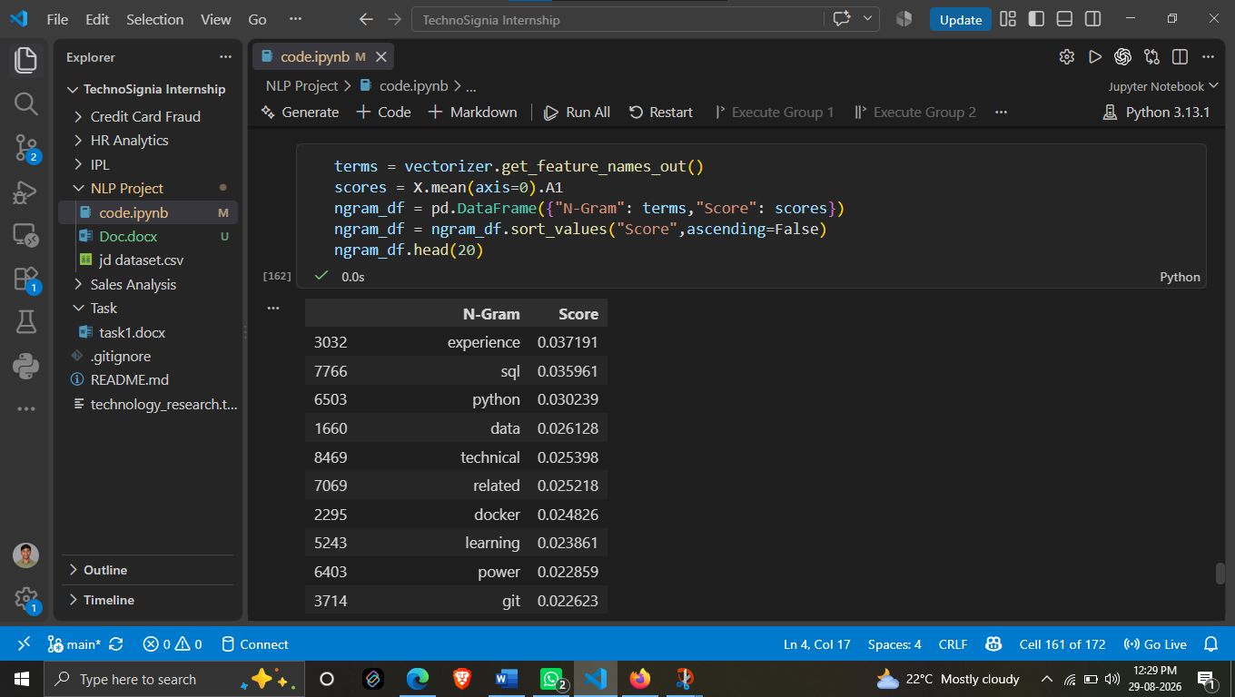The analysis shows that SQL and Python are among the important technical terms in the Job Description dataset. Docker and Git also appear among the higher-scoring terms.
Overall Importance
N-Gram analysis helps us understand the word patterns and phrases used in Job Descriptions. Unigrams provide individual terms, while bigrams and trigrams help capture multi-word expressions.
This analysis is useful for our project because skills are not always represented by a single word. Multi-word skills such as Machine Learning, Power BI and Natural Language Processing can be better represented using N-Grams.
Therefore, N-Gram analysis provides additional information that can support the later Job Skill Extraction process.

Bigram Analysis Results
The Bigram analysis was performed to identify important two-word combinations occurring in the Job Description dataset. The bigrams were assigned scores using TF-IDF, and the results were sorted based on their scores.
Some of the important bigrams identified were:
 | Bigram | Score
821 | machine learning | 0.035470
1327 | work projects | 0.032857
622 | improving performance | 0.032857
746 | key responsibilities | 0.032857
1268 | technical problems | 0.032857
1070 | responsibilities include | 0.032857
1072 | results experience | 0.032857
1073 | role requires | 0.032857
963 | performance communicating | 0.032857
260 | communicating results | 0.032857
1137 | solving technical | 0.032857
979 | projects involving | 0.032857
978 | problems improving | 0.032857
1060 | related qualification | 0.032857
1032 | qualification candidate | 0.032857
1332 | years experience | 0.032776
1068 | requires years | 0.032155
972 | power bi | 0.031703
1071 | rest api | 0.030183
977 | preferred time | 0.028036

Trigram Analysis Results
The Trigram analysis was performed to identify important three-word combinations in the Job Description dataset. Trigrams provide more context than unigrams and bigrams because they consider three consecutive words together.
The following trigram results were obtained from the analysis:
 | Trigram | Score
7317 | work projects involving | 0.026503
6327 | solving technical problems | 0.026503
5332 | problems improving performance | 0.026503
1290 | communicating results experience | 0.026503
3461 | improving performance communicating | 0.026503
7034 | technical problems improving | 0.026503
5894 | related qualification candidate | 0.026503
4227 | key responsibilities include | 0.026503
5259 | performance communicating results | 0.026503
5990 | role requires years | 0.025941
5906 | requires years experience | 0.025735
5331 | preferred time opportunity | 0.022618
5992 | science related qualification | 0.021373
1289 | collaborate cross functional | 0.019715
1294 | cross functional teams | 0.019715
1239 | clean transform validate | 0.019522
7220 | transform validate data | 0.019522
429 | analyze business requirements | 0.019398
5902 | requirements convert technical | 0.019398
1135 | business requirements convert | 0.019398
Observation
The analysis shows that several three-word combinations occur frequently and provide useful context about the Job Descriptions.
Some notable trigrams include “solving technical problems,” “key responsibilities include,” “cross functional teams,” “transform validate data,” and “analyze business requirements.”
The trigram “science related qualification” is also relevant because it represents a qualification-related phrase commonly associated with technical and data-oriented roles.
Trigrams such as “clean transform validate” and “transform validate data” provide useful information about data-related activities and responsibilities.
Overall, Trigram analysis helps capture longer phrases and contextual information that may not be visible when analyzing individual words or two-word combinations. This makes it useful for understanding Job Description requirements and supporting the identification of meaningful phrases during the Job Skill Extraction using NLP process.

Day 11
JOB CATEGORY SIMILARITY ANALYSIS
1. Introduction
Day 11 focuses on identifying the most relevant job category for a Job Description using similarity-based NLP analysis.
In this step, the Job Description is compared with a predefined set of job-related categories. A similarity score is calculated for each category. The category with the highest similarity score is considered the most relevant category for the given Job Description.
This approach helps us understand which technical or professional domain a particular Job Description is most closely related to.

2. Job Categories Used for Analysis
The analysis was performed using different job and technology-related categories, including:
- Data Engineering
- Data Analytics
- Web Development
- Database
- Programming
- Big Data
- DevOps
- Machine Learning
- Deep Learning
- Generative AI
- Cloud
- NLP
These categories represent different technical domains that can be associated with Job Descriptions.

3. Similarity Scores
The following similarity scores were obtained from the analysis:
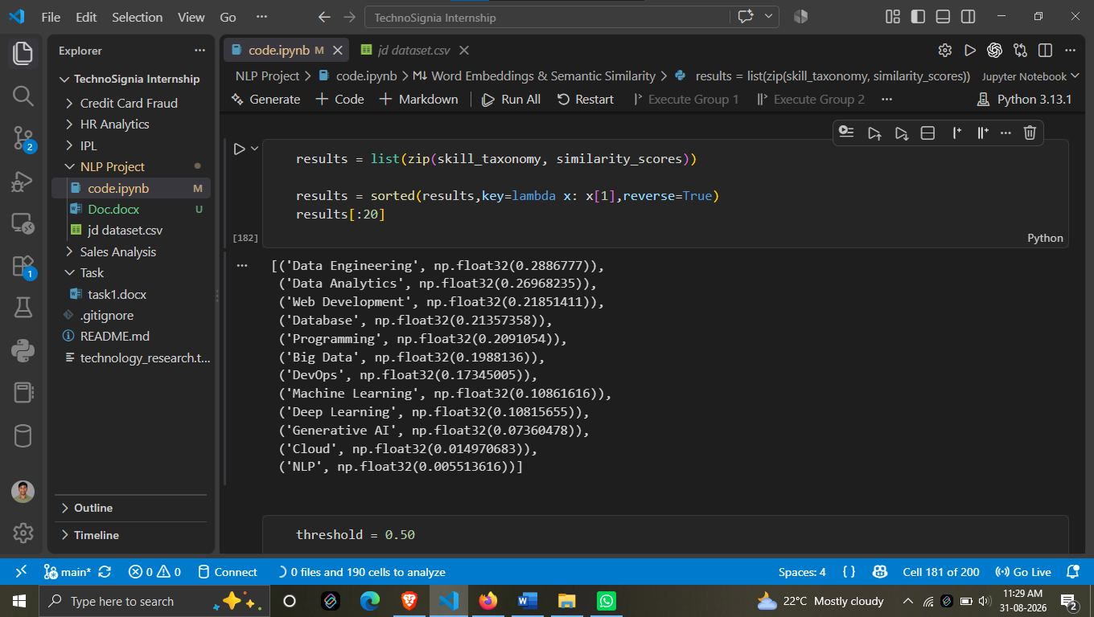
The similarity score represents how closely the analyzed text is related to each category. A higher score indicates stronger similarity with that category.

4. Analysis and Interpretation
The highest similarity score was obtained for Data Engineering, with a score of approximately 0.288678.
The second-highest score was for Data Analytics, with a score of approximately 0.269682.
Other categories with relatively higher scores were:
- Web Development – 0.218514
- Database – 0.213574
- Programming – 0.209105
- Big Data – 0.198814
On the other hand, Cloud and NLP received much lower similarity scores of approximately 0.014971 and 0.005514, respectively.
This shows that, for the analyzed text, the similarity was stronger with Data Engineering and Data Analytics compared with categories such as Cloud and NLP.

5. Importance in the Job Skill Extraction Project
Category similarity analysis can help extend the project beyond simply extracting individual skills.
For example, after extracting skills such as SQL, Python, Docker, AWS, and other technologies, similarity analysis can help determine the broader technical category associated with the Job Description.
This can be useful for:
- Understanding the technical domain of a job.
- Grouping Job Descriptions into relevant categories.
- Supporting job classification.
- Comparing a Job Description with different technical domains.
- Improving the overall understanding of extracted skills.
The similarity scores provide a quantitative way to compare the Job Description against multiple categories.

Day 12
NAMED ENTITY RECOGNITION & CUSTOM ENTITY EXTRACTION
1. Introduction
Day 12 focused on extracting important entities from the cleaned Job Descriptions. The main objective was to convert unstructured Job Description text into structured and meaningful information.
Two types of entity extraction were performed:
- Standard Entity Extraction
- Custom Entity Extraction
The standard extraction identifies general entities from the text, while custom extraction focuses on technical entities that are important for the Job Skill Extraction project.
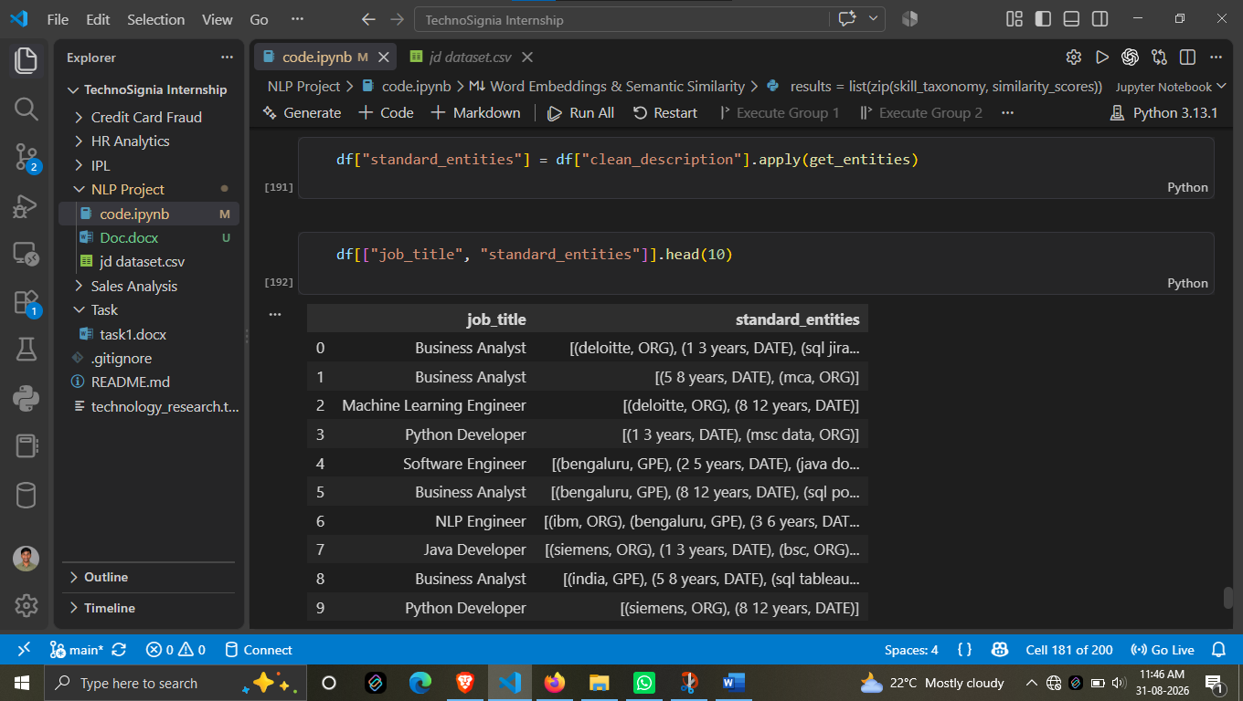

2. Standard Entity Extraction
Standard entity extraction was performed on the cleaned Job Descriptions to identify meaningful information present in the text.
The extracted information was stored in the standard_entities field and analyzed along with the corresponding Job Title.
The output contains different types of information, such as:
- Organization names – Deloitte, Siemens, IBM
- Locations – Bengaluru
- Experience – 1–3 years, 5–8 years, 8–12 years
- Qualifications – MCA, BSc
- Technical information – SQL, Java and other technologies
For example, the output shows that different Job Titles such as Business Analyst, Machine Learning Engineer, Python Developer, Software Engineer, NLP Engineer and Java Developer have different entities associated with their Job Descriptions.
This step helps separate important information from the original Job Description and makes it easier to analyze.
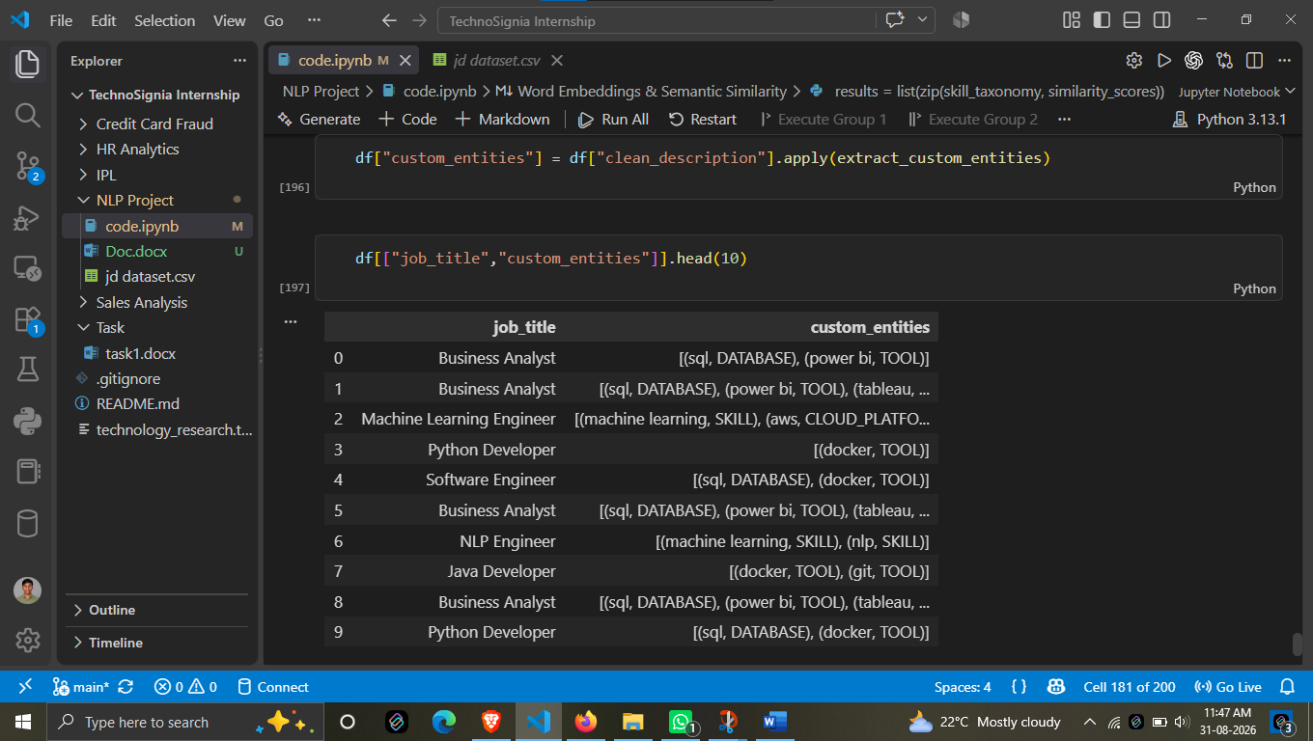

3. Custom Entity Extraction
Standard entity extraction may not provide the exact categories required for our project. Therefore, custom entity extraction was performed to identify technical entities specific to Job Descriptions.
The extracted information was stored in the custom_entities field.
The custom extraction classified technical terms into categories such as:
- SKILL
- TOOL
- DATABASE
- CLOUD_PLATFORM
For example:
Technical Entity | Category
SQL | DATABASE
Power BI | TOOL
Docker | TOOL
Git | TOOL
Machine Learning | SKILL
NLP | SKILL
AWS | CLOUD_PLATFORM
This classification gives more useful information than simply identifying the word.

4. Results from Job Descriptions
The output shows how technical entities are associated with different Job Titles.
For example:
Business Analyst
- SQL → DATABASE
- Power BI → TOOL
- Tableau → TOOL
Machine Learning Engineer
- Machine Learning → SKILL
- AWS → CLOUD_PLATFORM
Python Developer
- Docker → TOOL
Software Engineer
- SQL → DATABASE
- Docker → TOOL
NLP Engineer
- Machine Learning → SKILL
- NLP → SKILL
Java Developer
- Docker → TOOL
- Git → TOOL
This shows that the system is able to identify technical information and categorize it according to its type.

5. Importance of Custom Entity Extraction
Custom entity extraction is particularly useful for our Job Skill Extraction using NLP project because Job Descriptions contain many different types of technical requirements.
For example, knowing that a Job Description contains SQL is useful, but knowing that SQL belongs to the DATABASE category provides additional structured information.
Similarly:
- Machine Learning can be treated as a SKILL
- Docker can be treated as a TOOL
- SQL can be treated as a DATABASE
- AWS can be treated as a CLOUD_PLATFORM
This structured information can later be used for analyzing technical requirements across different jobs.

Day 13
Preparing Training Data for the Skill Classifier
This screenshot shows the data preparation stage for building the Machine Learning Skill Classifier.
The existing custom_entities data contains extracted entities along with their corresponding labels. These entities are converted into a structured training dataset containing two main components:
- Text – the extracted technical entity.
- Label – the category assigned to that entity.
For example, the extracted information can have relationships such as:
- SQL → DATABASE
- Docker → DEVOPS_TOOL
- Machine Learning → SKILL
- Python → PROGRAMMING_LANGUAGE
The process goes through the custom entities available for each Job Description and separates the entity text and its category label. Each entity-label pair is then added to the training data.
After collecting all the examples, the training data is converted into a DataFrame named training_df. This creates a structured dataset that can be used as input for the Machine Learning classification pipeline.
Purpose of This Step
The main purpose is to transform the previously extracted custom entities into labeled training examples.
The flow is:

Custom Entities

Entity Text + Label

Training Data

Training DataFrame

ML Classifier
This step is important because the Logistic Regression classifier used later needs labeled examples to learn how different technical terms belong to different categories.

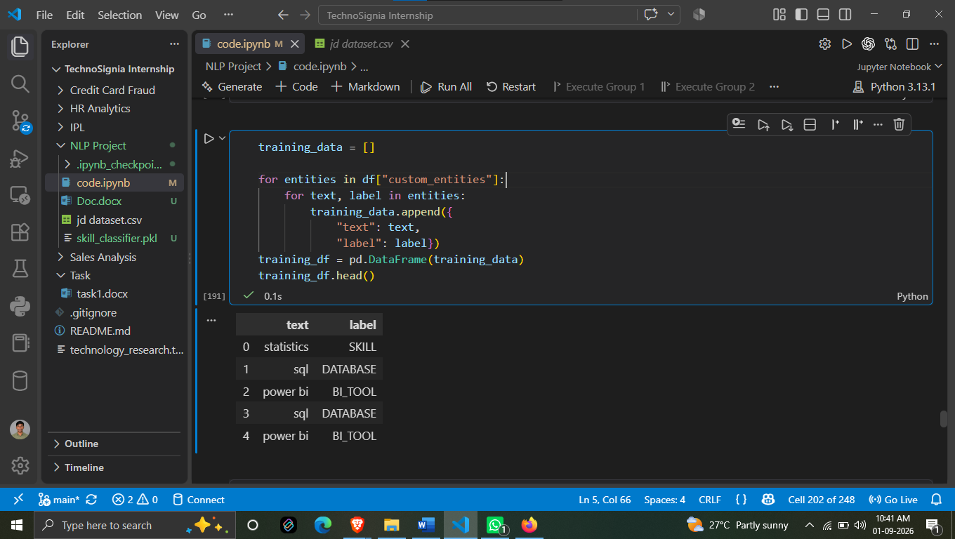

Total Training Examples
The prepared dataset contains 71,106 training examples.
These examples were created from the custom entities extracted from the Job Descriptions. Each example consists of an entity and its corresponding category label.
A large number of training examples provides the classifier with sufficient data to learn patterns between technical terms and their respective categories.

Observation
The SKILL category contains the highest number of examples with 15,920, making it the largest class in the training dataset.
The DEVOPS_TOOL and DATABASE categories also contain a significant number of examples, with 12,019 and 10,645 respectively.
On the other hand, BIG_DATA has the lowest number of examples among the displayed categories, with 1,253 examples.
This distribution is important because the Machine Learning model learns from these labeled examples. The different category sizes also show that the dataset is not perfectly balanced, as some categories have considerably more examples than others.
Overall, the output confirms that a large labeled dataset of 71,106 examples has been successfully prepared for training the Skill Classification model.

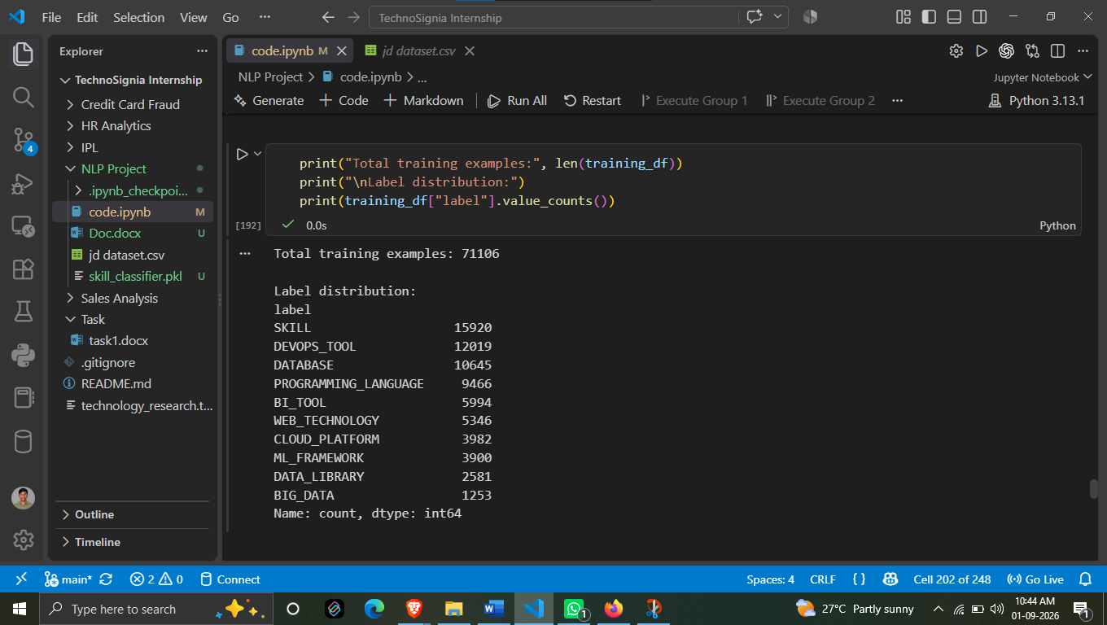

1. Machine Learning Pipeline
A Machine Learning pipeline was created using two main stages:
TF-IDF Vectorization → Logistic Regression
The TF-IDF Vectorizer converts the text-based technical entities into numerical features that the Machine Learning model can process.
The model uses a 1–2 n-gram range, which means it considers both:
- Individual words (unigrams)
- Two-word combinations (bigrams)
This is useful because some technical terms can contain more than one word, such as Machine Learning.
After feature extraction, Logistic Regression is used as the classifier to predict the appropriate entity category.

2. Model Training
The prepared training data is supplied to the pipeline for model training.
During this stage, the Logistic Regression model learns patterns between the extracted technical entity text and its predefined categories, such as:
- SKILL
- DEVOPS_TOOL
- DATABASE
- PROGRAMMING_LANGUAGE
- BI_TOOL
- WEB_TECHNOLOGY
- CLOUD_PLATFORM
- ML_FRAMEWORK
The screenshot confirms that the complete pipeline was successfully trained without an execution error.

3. Prediction on Test Data
After training, the model is used to make predictions on the test dataset.
The purpose of using test data is to check whether the trained classifier can correctly classify entities that were not used during the training process.
This provides a better indication of how the model performs on unseen data.

4. Model Accuracy
The screenshot shows the following result:
Accuracy: 0.21428571428571427
This is approximately 21.43% accuracy.
This means that the model correctly classified about 21.43% of the test examples.
Observation
The accuracy is relatively low, which indicates that the current TF-IDF + Logistic Regression approach is not yet performing strongly for this multi-category technical entity classification task.
Possible reasons may include the large number of categories, similarities between technical terms, and the uneven distribution of training examples across categories.
However, this model provides an important baseline for the project. Its performance can be evaluated and improved in later stages using better feature engineering, improved training data, or more advanced NLP/Transformer-based approaches.
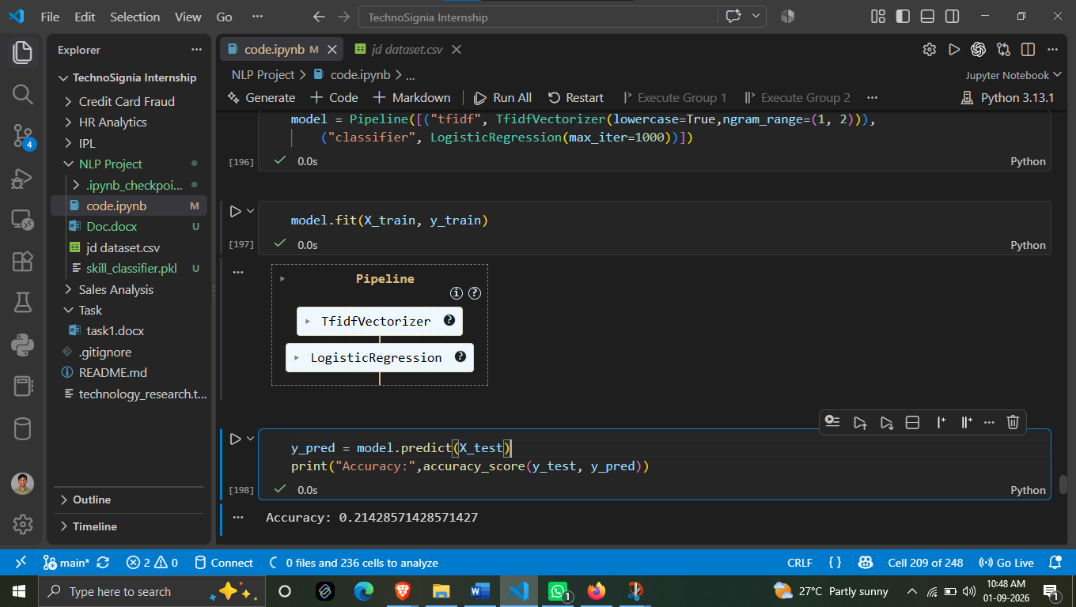

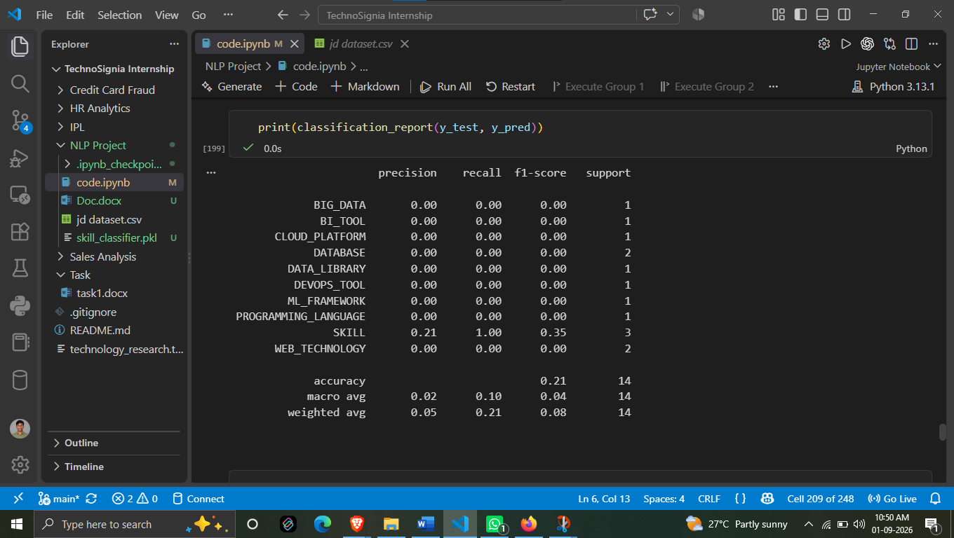

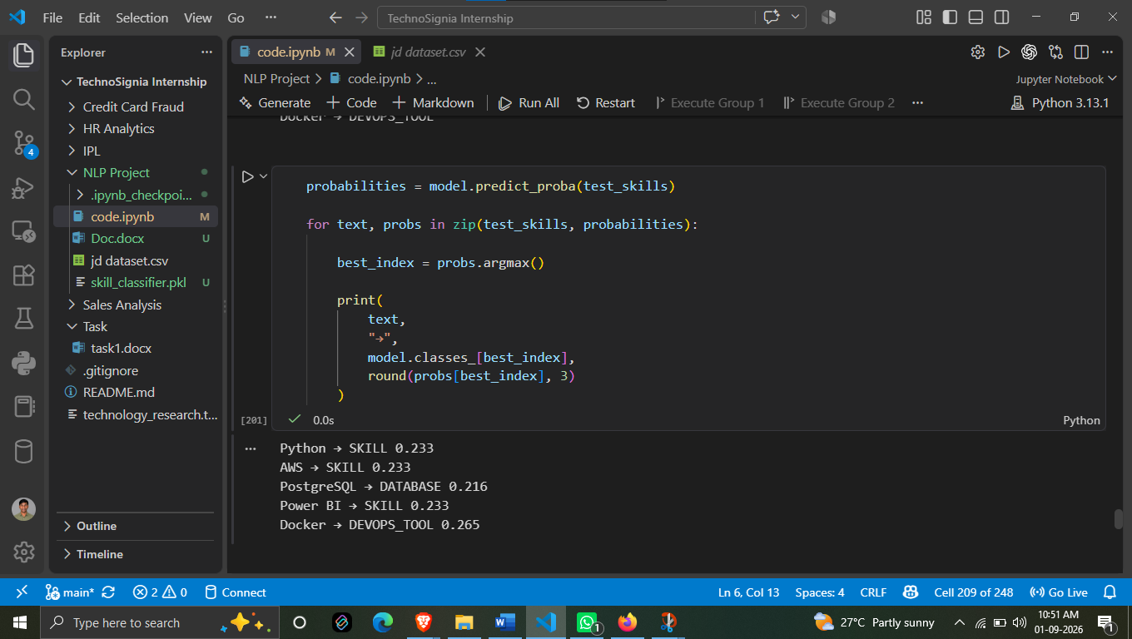

DAY 14
Alternative Approach for Skill Extraction
1. Overview
In Day 14, an alternative approach was used for skill/entity extraction because the previously considered NER model was not running properly.
The screenshot shows that a transformer-based NER model (dslim/bert-base-NER) was considered, but instead of depending on that model, a custom rule-based extraction approach was implemented.
This approach uses the existing skill taxonomy to identify skills directly from the Job Description text.

2. Why an Alternative Approach Was Used
The NER model approach was not working as expected in the project environment. Therefore, another method was required to continue the skill extraction process.
Instead of stopping the project because of the model issue, a dictionary/taxonomy-based approach was used.
The advantage of this approach is that it does not require a Transformer NER model to run. It directly checks whether known skills from the project's skill taxonomy are present in the Job Description.

3. Skill Taxonomy-Based Extraction
The implemented approach uses the existing skill_taxonomy as the reference list.
The Job Description is converted into lowercase text so that skill matching becomes case-insensitive.
The system then goes through the skill categories and their associated keywords.
For example, if the taxonomy contains a skill with keywords such as:
- Python
- SQL
- Machine Learning
- NLP
the system checks whether these keywords are present in the Job Description.
When a matching keyword is found, it is added to the extracted results.

4. Extracted Information
For every matched skill, the system stores three important pieces of information:
- Word – the matched skill/keyword
- Entity Group – the skill category from the taxonomy
- Score – a confidence/value assigned to the matched entity
The screenshot shows the score being assigned as 1.0 for a successful taxonomy match.
Therefore, the output provides structured information such as:
Word → Entity Group → Score
This makes the extracted skill information easier to use in later stages of the project.

5. How the Alternative Method Works
The overall process can be understood as:
Job Description
↓
Convert Text to Lowercase
↓
Check Skill Taxonomy
↓
Search for Matching Keywords
↓
Identify Matching Skills
↓
Assign Entity Group
↓
Assign Score
↓
Return Extracted Entities
This approach provides a direct and controlled way to identify known technical skills from Job Descriptions.
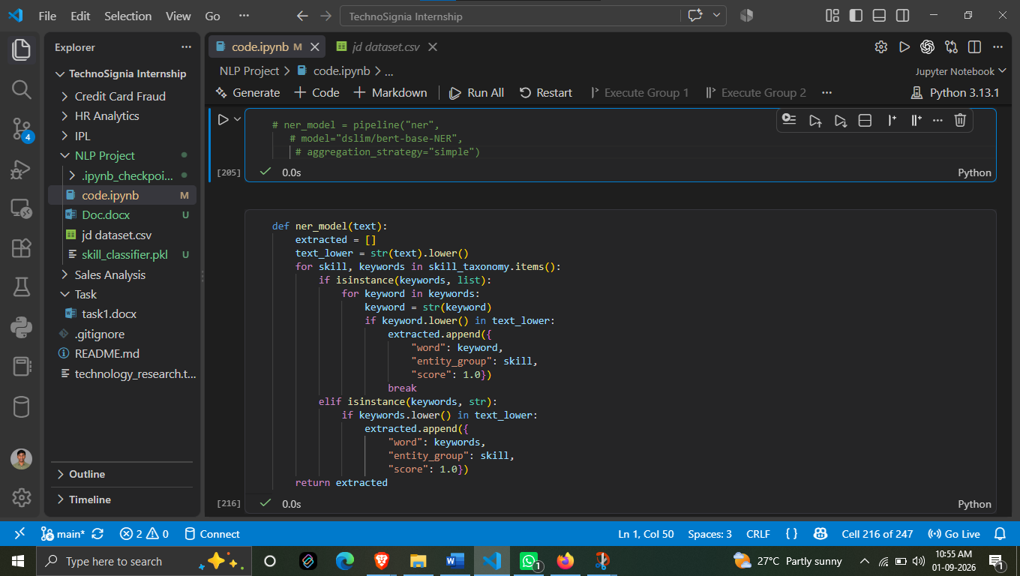

1. Applying Transformer Entity Extraction
The cleaned Job Description text was processed to identify relevant technical entities. The extracted information was then added to the dataset so that each Job Description could be analyzed along with its corresponding Job Title.
The output displays the first 10 records with:
- Job Title
- Transformer Entities
This allows us to compare different job roles with the technical entities identified from their descriptions.
2. Extracted Entity Information
The output shows that the extracted entities are represented with three components:
Entity → Category → Score
For example, the screenshot shows entities such as:
- C → Programming → 1.0
- SQL → Database → 1.0
- Python → Programming → 1.0
- Docker → DevOps → 1.0
- Java → Programming → 1.0
- Transformer → Deep Learning → 1.0
This means that the system is not only identifying the technical term but also assigning it to a relevant technical category.
3. Examples from the Output
Different Job Titles produce different combinations of technical entities.
Business Analyst
The output contains entities such as C under Programming and SQL under Database.
Machine Learning Engineer
The output contains entities such as Python under Programming and SQL under Database.
Python Developer
The output identifies Python as Programming and Docker as DevOps.
Software Engineer
The output identifies Java as Programming and SQL as Database.
NLP Engineer
The output includes Python under Programming and Transformer under the Deep Learning category.
Java Developer
The output identifies Java as Programming and Docker as DevOps.
4. Score
The extracted entities shown in the screenshot have a score of 1.0.
This score represents the confidence/value assigned by the implemented extraction approach to the identified entity.
5. Observation
The output demonstrates that the system can extract technical entities from different Job Descriptions and organize them into meaningful categories such as Programming, Database, DevOps and Deep Learning.
This is useful for the Job Skill Extraction project because the extracted information can be connected with the Job Title and later used for skill analysis and understanding the technical requirements of different roles.
Conclusion
The Transformer Entity Extraction step successfully generated structured technical entity information for the Job Descriptions. The output contains the entity name, its technical category and score, making the extracted information more structured and useful for further analysis.

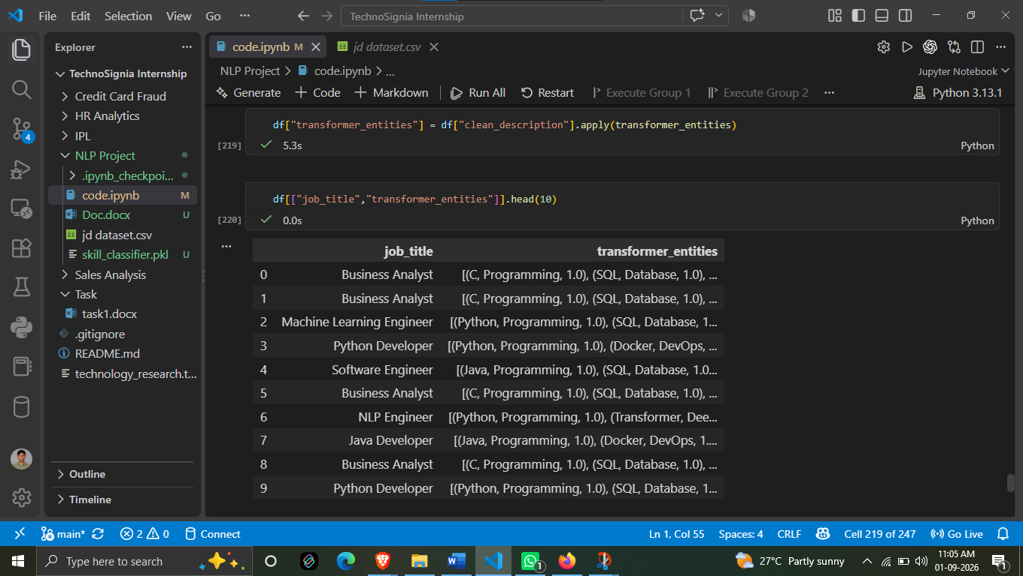

1. Purpose of the Comparison
The purpose of this step is to compare the results produced by the two extraction approaches for the same Job Descriptions.
This helps us understand whether both methods are identifying similar technical information and how they categorize the extracted entities.

2. Custom Entities
The custom_entities column contains entities extracted using the project's custom taxonomy-based approach.
The output shows categories such as:
- SKILL
- DATABASE
- BI_TOOL
- PROGRAMMING_LANGUAGE
- WEB_TECHNOLOGY
For example, for a Business Analyst, the custom extraction identifies entities such as:
- Statistics → SKILL
- SQL → DATABASE
- Power BI → BI_TOOL
For a Python Developer, Python is identified as a PROGRAMMING_LANGUAGE.

3. Transformer Entities
The transformer_entities column contains the entities generated through the transformer-based extraction approach.
The output categorizes technical terms differently, for example:
- C → Programming
- Python → Programming
- Java → Programming
- SQL → Database
- Docker → DevOps
- Transformer → Deep Learning
Each extracted transformer entity also contains a score of 1.0 in the displayed results.

4. Comparison of Results
The comparison shows that both approaches are able to identify important technical terms from Job Descriptions, but their category naming and classification can differ.
For example:
Python Developer
- Custom Entity → Python → PROGRAMMING_LANGUAGE
- Transformer Entity → Python → Programming
Both approaches identify Python, but the category representation is different.
Similarly:
Software Engineer
- Custom Entity → Java → PROGRAMMING_LANGUAGE
- Transformer Entity → Java → Programming
- Custom Entity → SQL → DATABASE
- Transformer Entity → SQL → Database
This demonstrates that the two approaches can identify similar technical entities while representing their categories in different ways.

5. Importance of This Step
This comparison is useful because it allows us to evaluate the behavior of different entity extraction approaches on the same dataset.
It helps identify:
- Which technical entities are being detected
- How the entities are categorized
- Whether both approaches identify similar technologies
- Differences in category naming and classification
Conclusion
The screenshot represents a comparison stage between Custom Entity Extraction and Transformer Entity Extraction.
Both approaches successfully identify technical entities from Job Descriptions. However, the output shows differences in how those entities are categorized. This comparison helps us understand the strengths and differences of each extraction approach and provides a basis for selecting the most suitable method for the Job Skill Extraction project.

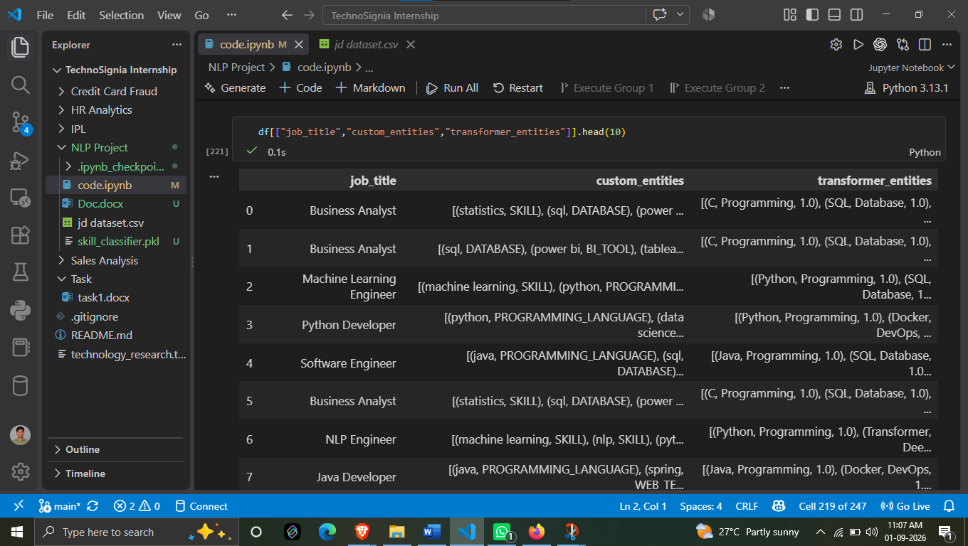

DAY 15
Model Evaluation
Preparing Actual Skills for Model Evaluation
This screenshot shows an important step in the Model Evaluation phase. Before evaluating the skill extraction model, the required_skills column from the dataset is converted into a standardized set of skills called true_skills.
Purpose of This Step
The main purpose is to create a reliable ground-truth dataset that can be compared with the skills predicted or extracted by the model.
The required_skills column contains skills in different formats. For example:
- SQL, JIRA, Power BI, Statistics
- Tableau, Power BI, Excel, Statistics, SQL
- Python, Scikit-learn, TensorFlow, Machine Learning...
- Python, REST API, Git, Docker, FastAPI, Django
To make comparison easier, these values are converted into sets of standardized, lowercase skill names.
What the Screenshot Shows
A new column named true_skills is created from the existing required_skills column.
For example:
Job Title | Required Skills | True Skills
Business Analyst | SQL, JIRA, Power BI, Statistics | {statistics, jira, power bi, sql}
Business Analyst | Tableau, Power BI, Excel, Statistics, SQL | {tableau, power bi, sql, excel, statistics}
Machine Learning Engineer | Python, Scikit-learn, TensorFlow, Machine Learning... | {machine learning, tensorflow, aws, scikit-learn...}
Python Developer | Python, REST API, Git, Docker, FastAPI, Django | {django, docker, rest api, python, fastapi, git}
The conversion also helps remove unnecessary differences such as uppercase/lowercase variations. For example, SQL and sql are treated as the same skill.
Why true_skills is Important
The true_skills column represents the actual or expected skills present in each job description. These values will act as the reference when checking the model's output.
The model's extracted skills can later be compared against these true skills to determine:
- Correctly detected skills
- Missing skills
- Incorrectly detected skills
- Precision
- Recall
- F1-score
- Overall model performance
Importance in the Project
This step is necessary because simply looking at model predictions is not enough to determine whether the model is performing well. We need a trusted reference or ground truth against which the predictions can be evaluated.
Therefore, creating true_skills provides a standardized basis for comparing the actual skills from the dataset with the skills extracted by the NLP/ML model.

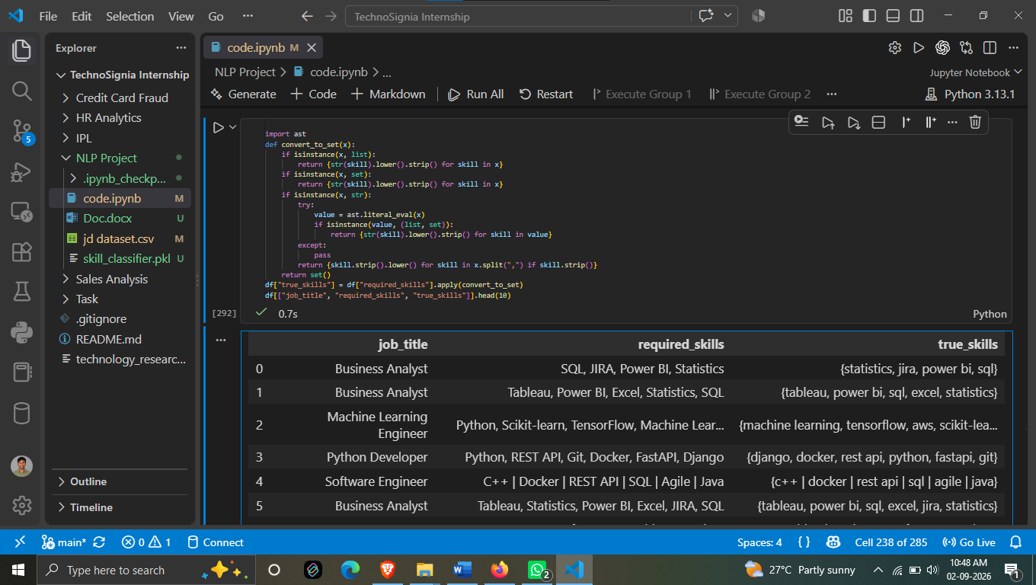

Evaluating Dictionary-Based Skill Extraction
This screenshot shows the evaluation of the Dictionary Matching method used for skill extraction. The predicted skills from the dictionary-based approach are compared with the true skills prepared earlier.
1. Dictionary Matching Evaluation
The evaluation compares:
- True Skills – the actual skills present in the job description.
- Dictionary Skills – the skills identified using the predefined skill dictionary.
The evaluation calculates four important performance metrics:
- Accuracy
- Precision
- Recall
- F1 Score
2. Evaluation Results
The screenshot shows the following results:
Metric | Score
Accuracy | 0.620
Precision | 0.583
Recall | 0.620
F1 Score | 0.601
3. Accuracy – 0.620
The accuracy is 0.620, which means the dictionary matching approach achieves an overall matching performance of approximately 62% according to the evaluation method used in the project.
This indicates that the dictionary-based approach is able to identify a considerable portion of the required skills, but there is still room for improvement.
4. Precision – 0.583
The precision is 0.583.
Precision indicates how accurate the extracted skills are — in other words, how many of the skills identified by the dictionary approach are actually relevant skills according to the ground truth.
A precision of approximately 58.3% shows that some extracted skills do not exactly match the expected skills.
5. Recall – 0.620
The recall is 0.620.
Recall measures how many of the actual skills present in the ground-truth data were successfully identified by the dictionary matching approach.
The result of 62% indicates that the method is able to capture a significant portion of the required skills, while some skills are still missed.
6. F1 Score – 0.601
The F1 Score is 0.601.
F1 Score provides a combined measure of precision and recall. Since both precision and recall are important for a skill extraction system, F1 Score gives a useful overall indication of the balance between correctly identifying skills and avoiding incorrect matches.
The F1 score of 60.1% indicates that the dictionary-based method provides a reasonable baseline for the project.
7. Overall Interpretation
The results show that Dictionary Matching provides a useful baseline for skill extraction, but it is not perfect. The method depends heavily on the predefined skill dictionary, so it may fail when a job description contains:
- New or previously unseen skills
- Different names or variations of the same skill
- Skills expressed using different terminology
- Context-dependent terms
Therefore, these evaluation results can be used as a baseline for comparing the dictionary approach with more advanced NLP or machine-learning approaches in the later stages of the project.
In short: The Dictionary Matching method achieved 62% accuracy, 58.3% precision, 62% recall, and 60.1% F1 score, showing that it can identify many relevant skills but still requires improvement for more accurate and robust skill extraction.
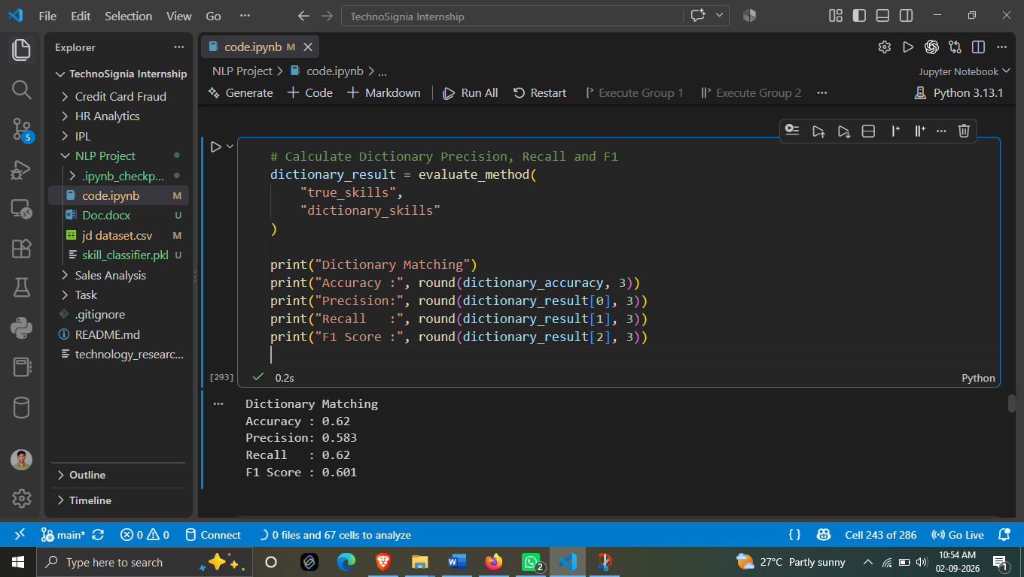

Evaluating Regex-Based Skill Matching
This screenshot shows the evaluation of the Regex Matching approach used for extracting skills from job descriptions. The Regex-based results are compared with the previously prepared true_skills ground-truth data.
1. Regex Matching
Regex (Regular Expression) matching is used to identify specific skill patterns or keywords from job descriptions. After extracting the skills, the results are evaluated against the actual skills in the dataset.
The evaluation focuses on three important metrics:
- Precision
- Recall
- F1 Score
2. Evaluation Results
The screenshot shows the following results:
Metric | Score
Precision | 0.567
Recall | 0.052
F1 Score | 0.096
3. Precision – 0.567
The Regex Matching approach achieved a precision of 0.567, or approximately 56.7%.
This means that when the Regex method identifies a skill, a reasonable portion of those identified skills correspond to the expected skills. However, some extracted results do not match the ground-truth skills.
4. Recall – 0.052
The recall is only 0.052, which is approximately 5.2%.
This is the main weakness of the Regex Matching approach. It means that the method is identifying only a small portion of the actual skills present in the ground-truth data.
Many relevant skills are therefore being missed by the Regex approach.
5. F1 Score – 0.096
The F1 Score is 0.096, approximately 9.6%.
F1 Score combines Precision and Recall into a single metric. Because the recall is very low, the overall F1 Score is also very low.
This indicates that although Regex Matching can correctly identify some skills, it does not provide sufficient coverage of all the skills present in the job descriptions.
6. Overall Interpretation
The results indicate that Regex Matching performs poorly compared with the Dictionary Matching approach evaluated earlier.
The major issue is the very low Recall (5.2%). Regex patterns are generally dependent on predefined patterns and exact or expected text structures. As job descriptions can contain different skill names, wording variations, and descriptions, a limited set of patterns may fail to capture many relevant skills.
Therefore, Regex Matching can be useful for detecting specific and well-defined patterns, but it is not sufficient as the primary skill extraction technique for this project.
7. Conclusion of This Evaluation
The Regex approach achieved:
Precision = 56.7% | Recall = 5.2% | F1 Score = 9.6%
The relatively moderate precision but extremely low recall shows that the method can identify some relevant skills, but it misses most of the actual skills. This demonstrates why more robust approaches such as Dictionary Matching, Machine Learning, and NLP-based methods need to be considered for improving the overall skill extraction system.

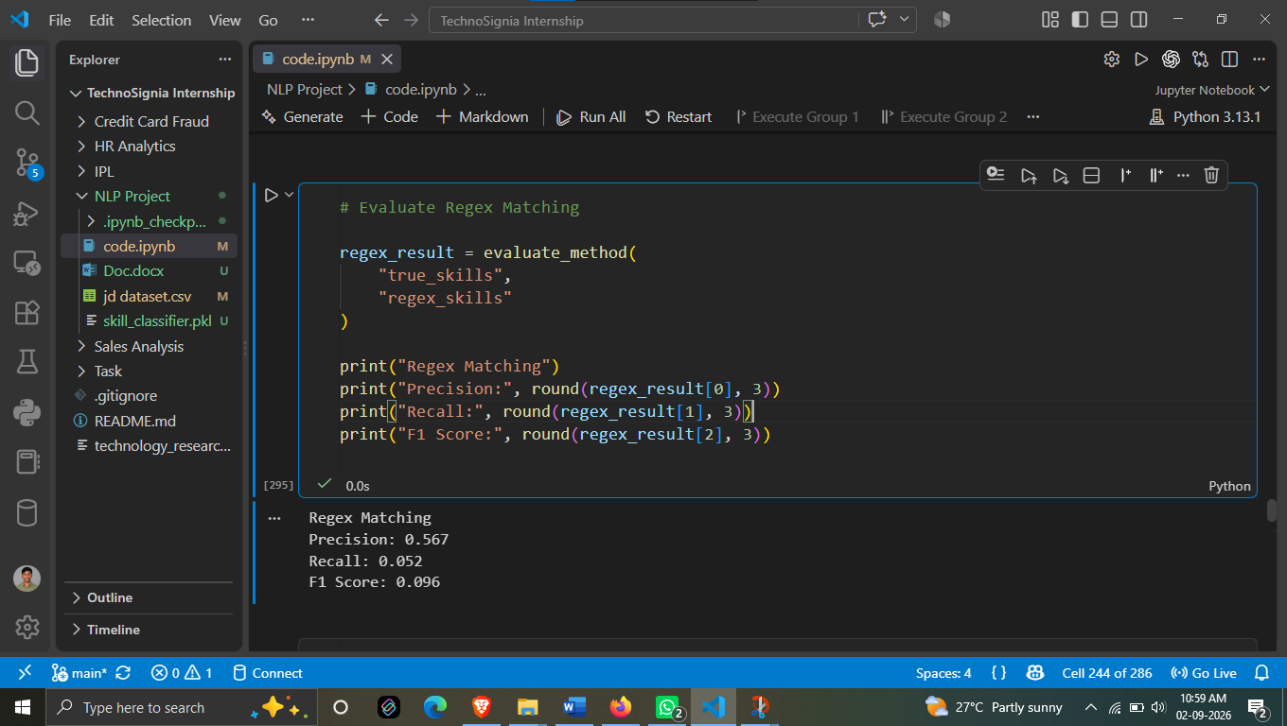

Evaluating the Semantic Similarity Approach
This screenshot shows the evaluation of the Semantic Similarity approach for skill extraction. In this method, the extracted skills are evaluated against the true skills prepared from the dataset.
1. Purpose of Semantic Similarity Evaluation
Semantic similarity is used to determine whether the predicted skills are related in meaning to the actual skills, rather than relying only on exact text matching.
The evaluation compares the true skills with the skills generated by the semantic similarity approach and calculates:
- Precision
- Recall
- F1 Score
2. Evaluation Results
The screenshot shows the following results:
Metric | Score
Precision | 0.852
Recall | 0.036
F1 Score | 0.069
3. Precision – 0.852
The Semantic Similarity approach achieved a precision of 0.852, which is approximately 85.2%.
This is the highest precision among the approaches shown so far. It indicates that when the semantic similarity method identifies a skill, a large proportion of those identified skills are relevant to the expected skills.
This suggests that the semantic approach is relatively good at identifying relevant or semantically related skills.
4. Recall – 0.036
The recall is 0.036, which is approximately 3.6%.
This is very low. It indicates that the approach is identifying only a small portion of all the actual skills present in the ground-truth data.
Therefore, although the predictions that are made are often relevant, many actual skills are not being detected.
5. F1 Score – 0.069
The F1 Score is 0.069, or approximately 6.9%.
F1 Score considers both precision and recall. In this case, the precision is high, but the recall is extremely low. As a result, the overall F1 Score remains low.
This demonstrates an important characteristic of the current semantic similarity implementation: it produces relatively precise matches but does not cover enough of the true skills.
6. Overall Interpretation
The result can be summarized as:
High Precision + Very Low Recall = Low F1 Score
The 85.2% precision is encouraging because it shows that the extracted results are generally relevant. However, the 3.6% recall shows that a large number of required skills are still missed.
Therefore, based on this evaluation, the Semantic Similarity approach in its current implementation is not sufficient as a standalone skill extraction method.
7. Comparison with Previous Results
Method | Precision | Recall | F1 Score
Dictionary Matching | 0.583 | 0.620 | 0.601
Regex Matching | 0.567 | 0.052 | 0.096
Semantic Similarity | 0.852 | 0.036 | 0.069
The comparison shows that Semantic Similarity has the highest precision (85.2%), while Dictionary Matching has much better recall (62%) and F1 Score (60.1%) among these three approaches.
This comparison is useful for understanding the strengths and limitations of each skill extraction technique before selecting or improving the final approach.

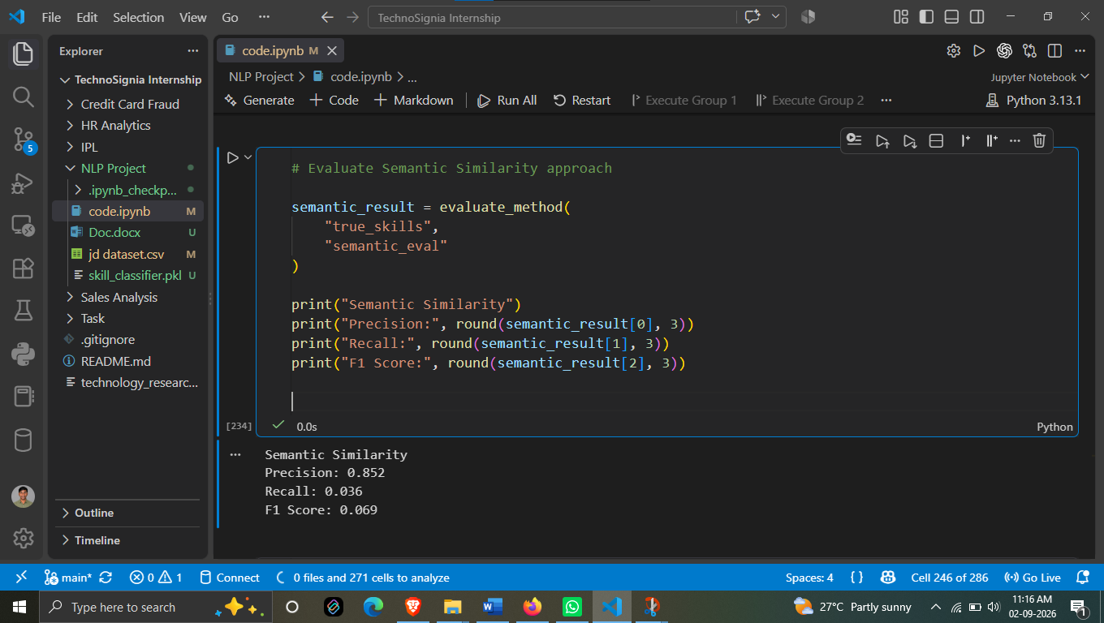

Evaluating Transformer-Based Skill Extraction
This screenshot shows the evaluation of the Transformer-based skill extraction approach. The extracted skills from the Transformer method are compared with the previously prepared true skills (ground-truth data) to measure the model's performance.
1. Transformer-Based Extraction
A Transformer-based approach is used to identify skills from job descriptions. Unlike simple keyword or Regex matching, this approach can use the context and language patterns present in the text to identify relevant entities.
For evaluation, the Transformer results are compared against the actual skills available in the true_skills data.
The evaluation measures three important metrics:
- Precision
- Recall
- F1 Score
2. Evaluation Results
The screenshot shows:
Metric | Score
Precision | 0.916
Recall | 0.636
F1 Score | 0.751
3. Precision – 0.916
The Transformer approach achieved a precision of 0.916, which is approximately 91.6%.
This is a very strong precision result. It means that most of the skills identified by the Transformer-based approach are relevant and match the expected skills.
The model therefore produces relatively few incorrect skill predictions.
4. Recall – 0.636
The recall is 0.636, or approximately 63.6%.
This means that the Transformer approach successfully identifies a significant portion of the actual skills present in the ground-truth data.
Compared with the Regex and Semantic Similarity approaches, this represents much better coverage of the actual required skills.
5. F1 Score – 0.751
The F1 Score is 0.751, which is approximately 75.1%.
F1 Score provides a balance between Precision and Recall. Since the Transformer approach has both high precision (91.6%) and a reasonably strong recall (63.6%), it achieves a much stronger F1 Score.
This indicates that the Transformer-based approach provides a better balance between correct skill identification and skill coverage.
6. Comparison with Previous Methods
The results from the approaches evaluated so far are:
Method | Precision | Recall | F1 Score
Dictionary Matching | 0.583 | 0.620 | 0.601
Regex Matching | 0.567 | 0.052 | 0.096
Semantic Similarity | 0.852 | 0.036 | 0.069
Transformer | 0.916 | 0.636 | 0.751
From these results, the Transformer approach gives the best overall performance among the four methods shown.
7. Overall Interpretation
The Transformer-based approach demonstrates strong performance for the current skill extraction task. Its 91.6% precision indicates highly relevant predictions, while its 63.6% recall shows that it captures a substantial proportion of the actual skills.
The resulting 75.1% F1 Score is the highest F1 Score among the evaluated approaches, making the Transformer method the strongest approach in this evaluation.
Conclusion: Based on the evaluation results shown in the screenshot, the Transformer-based extraction method performs better overall than Dictionary Matching, Regex Matching, and Semantic Similarity for the current dataset and evaluation setup.
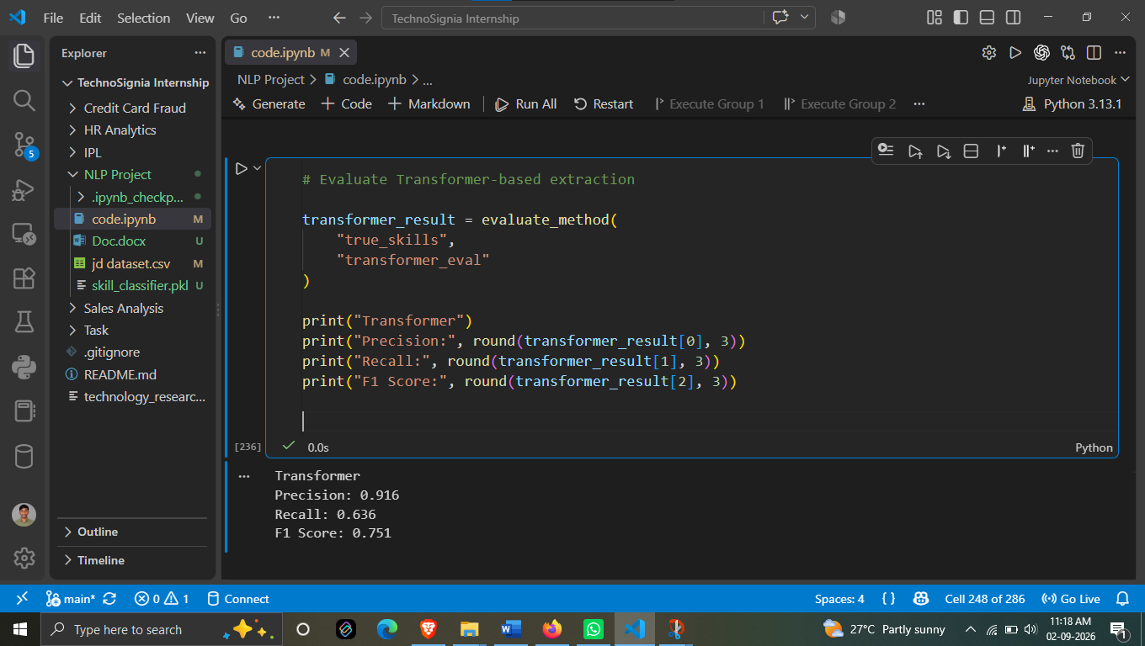

FINAL SKILL EXTRACTION COMPARISON

The main objective of Day 15 was to evaluate and compare different skill extraction methods used in the NLP project. The performance of each method was measured using Accuracy, Precision, Recall, and F1 Score.
Four approaches were evaluated:
- Dictionary Matching
- Regex Matching
- Semantic Similarity
- Transformer-based Extraction
The final comparison shows that the Transformer method performed the best overall.
Method | Accuracy | Precision | Recall | F1 Score
Dictionary | 0.620 | 0.583 | 0.620 | 0.601
Regex | 0.052 | 0.567 | 0.052 | 0.096
Semantic Similarity | 0.036 | 0.852 | 0.036 | 0.069
Transformer | 0.636 | 0.916 | 0.636 | 0.751
Result Analysis
Dictionary Matching achieved an F1 Score of 0.601, showing that direct matching with the predefined skill dictionary was reasonably effective.
Regex Matching performed poorly, with an F1 Score of only 0.096. Although its precision was 0.567, its recall was very low, meaning that it failed to identify many of the relevant skills.
Semantic Similarity achieved a high precision of 0.852, but its recall was only 0.036. This means that when it identified a skill it was often correct, but it missed a large number of actual skills.
Transformer-based Extraction achieved the best overall performance, with 0.636 accuracy, 0.916 precision, 0.636 recall, and 0.751 F1 Score. Therefore, among the evaluated approaches, the Transformer method provided the most balanced and effective skill extraction performance.
Conclusion
The evaluation demonstrates that Transformer-based skill extraction is the strongest approach among the four methods tested. Its high precision and highest F1 Score indicate that it can identify relevant job skills more effectively while reducing incorrect predictions.

DAY 16
Error Analysis
1. Overview
Day 16 focuses on Error Analysis of the Skill Extraction Model.
After evaluating different skill extraction approaches in Day 15, the next step is to understand why the model makes incorrect predictions or misses some skills.
For this analysis, the true_skills column is used as the actual/reference skill data, while semantic_eval is selected as the predicted skill output for analysis.
The screenshot shows:
- Actual Column: true_skills
- Predicted Column: semantic_eval
This comparison helps identify the differences between the skills that are actually required and the skills detected by the selected extraction method.

2. Actual Skills and Predicted Skills
The actual skills (true_skills) represent the expected or ground-truth skills available in the Job Description.
The predicted skills (semantic_eval) represent the skills identified by the Semantic Similarity approach.
By comparing these two sets, we can determine which skills were correctly identified and which were not.
This is important because evaluation metrics such as Precision, Recall and F1 Score tell us how well the model performs, but error analysis helps us understand where and why the model is making mistakes.

3. False Positive and False Negative Analysis
The screenshot shows an error analysis process based on comparing the actual and predicted skill sets.
Two important types of errors are identified:
False Positive
A False Positive occurs when a skill is predicted by the model but is not present in the actual skill set.
For example:
Actual Skills:
SQL, Python, Docker
Predicted Skills:
SQL, Python, AWS
Here, AWS is a False Positive because the model predicted it, but it was not present in the actual skills.

False Negative
A False Negative occurs when a skill is present in the actual skill set but is not identified by the model.
For example:
Actual Skills:
SQL, Python, Docker
Predicted Skills:
SQL, Python
Here, Docker is a False Negative because it is an actual required skill but the model failed to extract it.

4. Set-Based Error Analysis
The error analysis treats both actual and predicted skills as sets.
This makes it possible to directly compare the two collections and identify:
- Skills predicted incorrectly
- Skills that were missed
- Differences between actual and predicted results
The analysis therefore provides a more detailed understanding of the model's behavior beyond the numerical evaluation metrics.

5. Importance of Error Analysis
Error analysis is an important step in improving the Job Skill Extraction system.
By identifying False Positives and False Negatives, we can understand the limitations of the current extraction method.
For example, errors may occur when:
- A skill is expressed using different terminology.
- Similar technical terms are confused.
- A relevant skill is not detected.
- The model identifies a related but incorrect skill.
- The semantic similarity threshold is not suitable.
Understanding these errors can help in improving the extraction approach in future iterations.

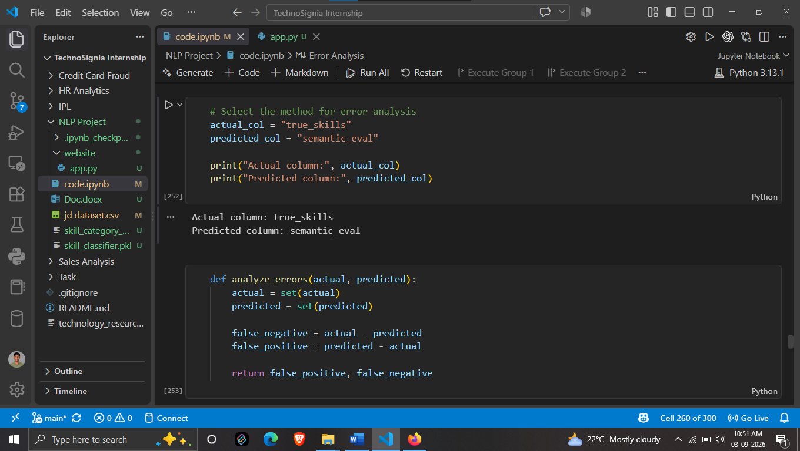
Identifying False Negative Errors
This screenshot shows the actual output of the Error Analysis performed on the skill extraction results.
The analysis identified a total of 23,148 errors in the selected evaluation results.
Error Analysis Output
The result contains four important columns:
- Text – the Job Description text in which the skill appears
- Actual – the skill that is actually present according to the ground-truth data
- Predicted – the skill identified by the model
- Error – the type of error identified
False Negative Analysis
The displayed errors are False Negatives.
A False Negative occurs when a skill is present in the actual/ground-truth skill set, but the selected method fails to identify it. Therefore, the Predicted value is shown as None.
For example, in the first record:
- Actual: SQL
- Predicted: None
- Error: False Negative
This means that SQL was an actual required skill, but the selected extraction method did not detect it.
Similarly, the analysis shows missed skills such as Statistics, Power BI, JIRA, Tableau, Excel, Scikit-learn, and Machine Learning.
Important Observation
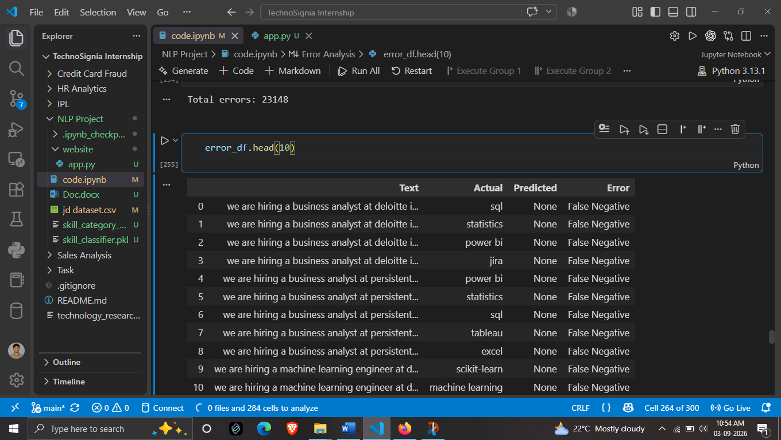
The output indicates that a significant number of errors are caused by missing skill predictions rather than incorrect skill predictions.This is consistent with the low recall observed for the Semantic Similarity approach during Day 15 evaluation. A low recall means that many skills that are actually present are not being extracted by the method.The 23,148 total errors provide a clear indication that further improvement is required in the current extraction approach.

Error Classification
This screenshot shows the next step in the Error Analysis process. After identifying the differences between the actual and predicted skills, each error is assigned to an Error Category.
The output contains the following columns:
- Text – the Job Description text
- Actual – the skill present in the ground-truth data
- Predicted – the skill identified by the model
- Error – the identified error type
- Error Category – the final classification of that error
Error Category
The screenshot shows that the errors identified in the previous step are classified under the False Negative category.
A False Negative occurs when a skill is present in the actual/ground-truth data but the extraction method fails to identify it. Therefore, the predicted value appears as None.
Purpose of This Step
Adding the Error Category makes the error analysis more structured. Instead of only knowing that an error occurred, we can clearly identify what type of error it is.
This makes it easier to analyze the model's weaknesses and understand whether errors are caused by:
- Missing skills (False Negative)
- Incorrectly predicted skills (False Positive)
- Other possible mismatches between actual and predicted results
Observation
In the displayed records, the Error and Error Category are both False Negative. This confirms that the selected method is mainly failing to detect skills that are actually present in the ground-truth data.For example, SQL, Statistics, Power BI, JIRA, Tableau, and Excel are actual skills, but the model prediction is None.
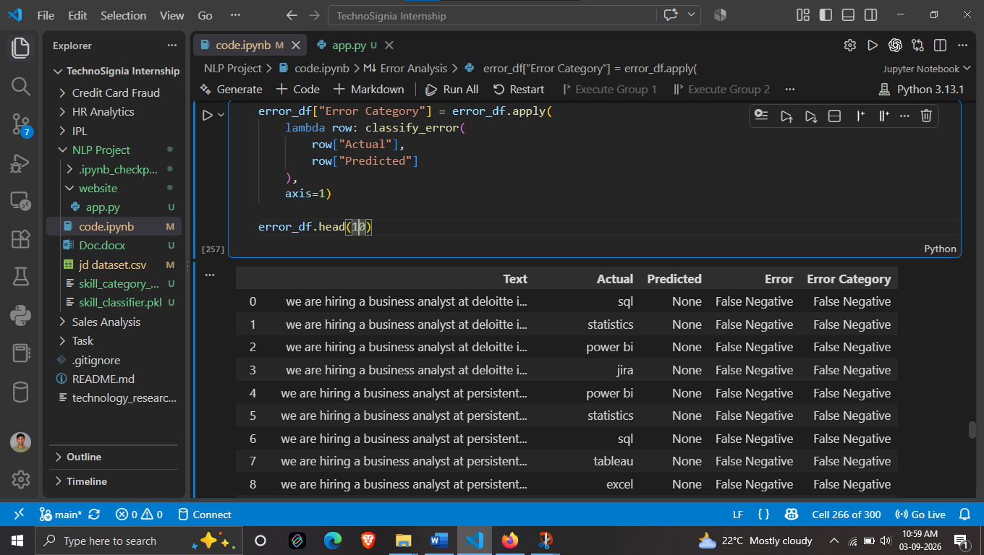

Error Summary
This screenshot presents the overall summary of the errors identified during the skill extraction error analysis. The errors are grouped into different categories, making it easier to understand the major types of mistakes made by the extraction approach.
Error Category Summary
Error Category | Count
False Negative | 18,286
Wrong Entity | 4,626
Partial Entity | 236
1. False Negative – 18,286
False Negative is the largest error category, with 18,286 errors.
This occurs when a skill is present in the actual/ground-truth data, but the extraction method fails to identify it.
The high number of False Negatives indicates that the current approach is missing a large number of relevant skills from the job descriptions.
2. Wrong Entity – 4,626
There are 4,626 Wrong Entity errors.
A Wrong Entity error occurs when the system identifies an entity, but the identified entity does not correctly correspond to the expected skill.
This indicates that the extraction method is sometimes detecting a wrong or unrelated entity instead of the required skill.
3. Partial Entity – 236
There are 236 Partial Entity errors.
A Partial Entity error occurs when the system identifies only a part of the expected entity rather than extracting the complete skill/entity.
For example, a multi-word skill may be partially identified instead of being captured as the complete skill.
Overall Observation
The error summary shows that False Negatives are the dominant source of errors, accounting for 18,286 cases. Wrong Entity errors are the second-largest category, while Partial Entity errors are comparatively small.
This indicates that the primary issue with the evaluated extraction approach is incomplete skill detection. The system needs to improve its ability to identify skills that are actually present in job descriptions.
Conclusion
The error summary provides a clear picture of where the skill extraction system is making mistakes:
18,286 False Negatives → 4,626 Wrong Entities → 236 Partial Entities
Therefore, reducing False Negative errors should be a major focus for improving the overall skill extraction performance.
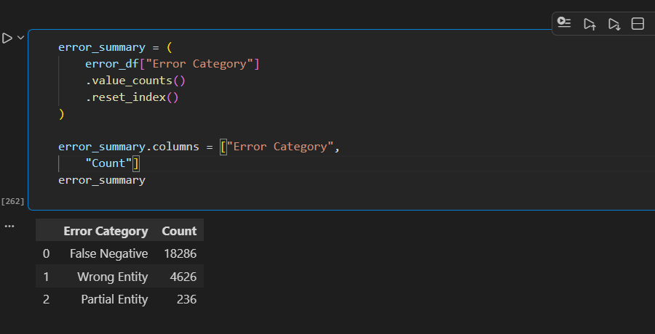

Partial Entity Error Analysis
This screenshot focuses specifically on the Partial Entity errors identified during the skill extraction error analysis.
The purpose of this step is to examine cases where the system does not completely match the actual skill set. The actual and predicted skills are compared to understand which skills were missed or only partially captured.
Partial Entity Examples
The screenshot contains examples such as:
What is a Partial Entity?
A Partial Entity occurs when the predicted result contains some of the expected skills but does not completely match the actual skill set.
For example, in the first record:
Actual:
SQL, Statistics, Power BI, JIRA
Predicted:
Power BI, SQL
Here, SQL and Power BI were successfully identified, but Statistics and JIRA were not detected. Therefore, the result is categorized as a Partial Entity.
Observation
The examples show that the extraction system is able to identify some relevant skills correctly, but it does not always capture the complete set of skills present in the job description.
For example, for the Python Developer description, the actual skills include:
REST API, FastAPI, Python, Django, Docker, Git
while the predicted skills are:
Docker, Python, REST API, Django
In this case, several skills are correctly extracted, but FastAPI and Git are missing.
Similarly, for the Software Engineer example, several skills such as Java, SQL, REST API, and Docker are detected, but the complete actual skill set is not captured.
Importance of This Analysis
Analyzing Partial Entity cases helps identify situations where the model is partially successful rather than completely wrong.
It shows that the system can recognize relevant skills but may have difficulty achieving complete skill coverage. These cases are particularly useful for understanding the gap between precision and recall.

